**A DBMS Project Report on**

**COVID-19 DATABASE**

# Index Page No

1. Problem Statement 2
2. Solution 2
3. System Architecture 3-4
4. Functional Requirements 5
5. Entities and their attributes 6
6. E-R /EER diagram 7
7. Entities and their relationships 8-9
8. Relational schema 9-10
9. CODD’S Rules 11
10. Description of tables 12-17
11. Functional Dependencies 18-28
12. Anomalies 29
13. Normalization 29-31
14. Queries 31-38
15. Functions 38-39
16. Procedures 40-41
17. Triggers 41-43

**Problem** –

As the pandemic is going on due to the Coronavirus and no safe and effective vaccine has been developed yet, the people catching this virus are being treated with the existing treatments.

Even the doctors are performing hit and trial, as there is no specific treatment available. The hit and trial method treatment sometimes turns out to be deadly because of the different intensity of the virus.

So, our project focuses on maintaining a record of all the necessary details of patient who has recovered from the virus. The record will include information such as the symptoms observed, doctor assigned and treatment given.

**Solution** – Since there is no specific treatment for Covid-19, this database would provide summary of patients along with their symptoms and treatment and whether it showed positive results on them, which will help doctors to treat their new patients with similar symptoms hence saving time and trials on them. This would also be beneficial for the patients who are self-quarantined.

**SYSTEM ARCHITECTURE**

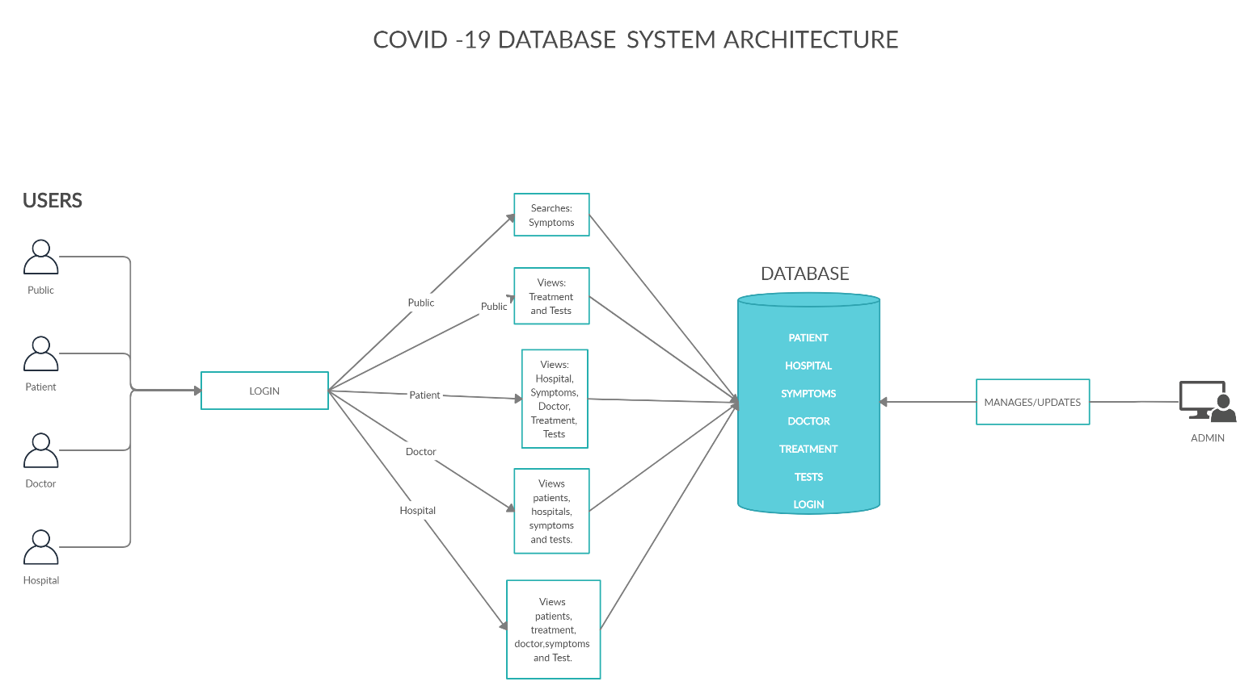

**System Architecture/Model –**

The model will be a website interacting with the users categorized into

* Hospitals
* General public
* Patient
* Doctors

The ADMIN will be responsible for updating all the details. Also, he will manage the website.

The users will be allowed to do the following-

1. The public will be able to search for symptoms and view the treatments and tests accordingly.

2. The patient will be able to view the details of doctor, hospital, tests, treatment and symptoms.

3. The doctor will be able to view the details of patients, hospital, tests, symptoms and treatment.

4. The hospital will be able to view the details of patients, doctor, symptoms, tests and treatment.  
  
  
  
  
  
  
  
  
  
  
  
  
  
**Functional Requirements-**

**The Covid-19 Management system will allow the hospitals to enter the details of the patients tested positive with Covid-19. This will help to keep a track of the patient’s journey with the virus. The system will also be helpful to the general public. The database will include features such as –**

* Login will have 5 types of users – admin, doctor, patient, hospital and. Public. Every user will have a unique login-id and password.
* Admin will manage the login page as well as update the details of patient, doctor, hospital, treatment, test and, symptoms.
* Every patient, hospital, doctor, treatment and symptom, test will be assigned a unique id.
* The patient will be either of type- symptomatic or asymptomatic.
* A patient will be either In-patient or Out-patient.
* Every patient will be registered with only one hospital.
* Every patient will be assigned one or more doctors.
* A doctor will be working in only one hospital and will have a specialization.
* Every Patient will take one or more tests. The test will be of different types.
* Every patient will have one or more symptoms and will receive treatment accordingly.
* The treatment will have two modes- hospitalized or home quarantined.
* There will be one or more treatment for every symptom.
* Every symptom and its treatment will have a start and end date.
* Symptoms will have different levels of severity.
* The patient will be able to view details of treatment, hospital, doctor, test and symptoms.
* The doctor will be able to view details of hospital, patient, symptoms, treatment and tests.
* The hospital will be able to view details of doctor, patient, symptoms, treatment and tests.
* The public will be able to search for one or many symptoms and will be able to view details of treatment and tests.

**Entities and Attributes**

* **Login :**  Login-id **,** Password
* **Admin :** Admin-id
* **Patient :** Name, Age, Gender, Type, P-id
* **In-Patient** : Admission date, Discharge date, Days of recovery
* **Out-Patient** : Registration date
* **Hospital :** Name, City, Area, H-id
* **Doctor :** Name, D-id, Specialization
* **Test :** Test id, Type , Test Name
* **Symptoms :** S-id , Name
* **Treatment :** T-id ,Name
* **Hospitalized :** HO-id , T-Name
* **Home-quarantined :** HQ-id , T-Name
* **Public :** Public-id

**ER DIAGRAM**

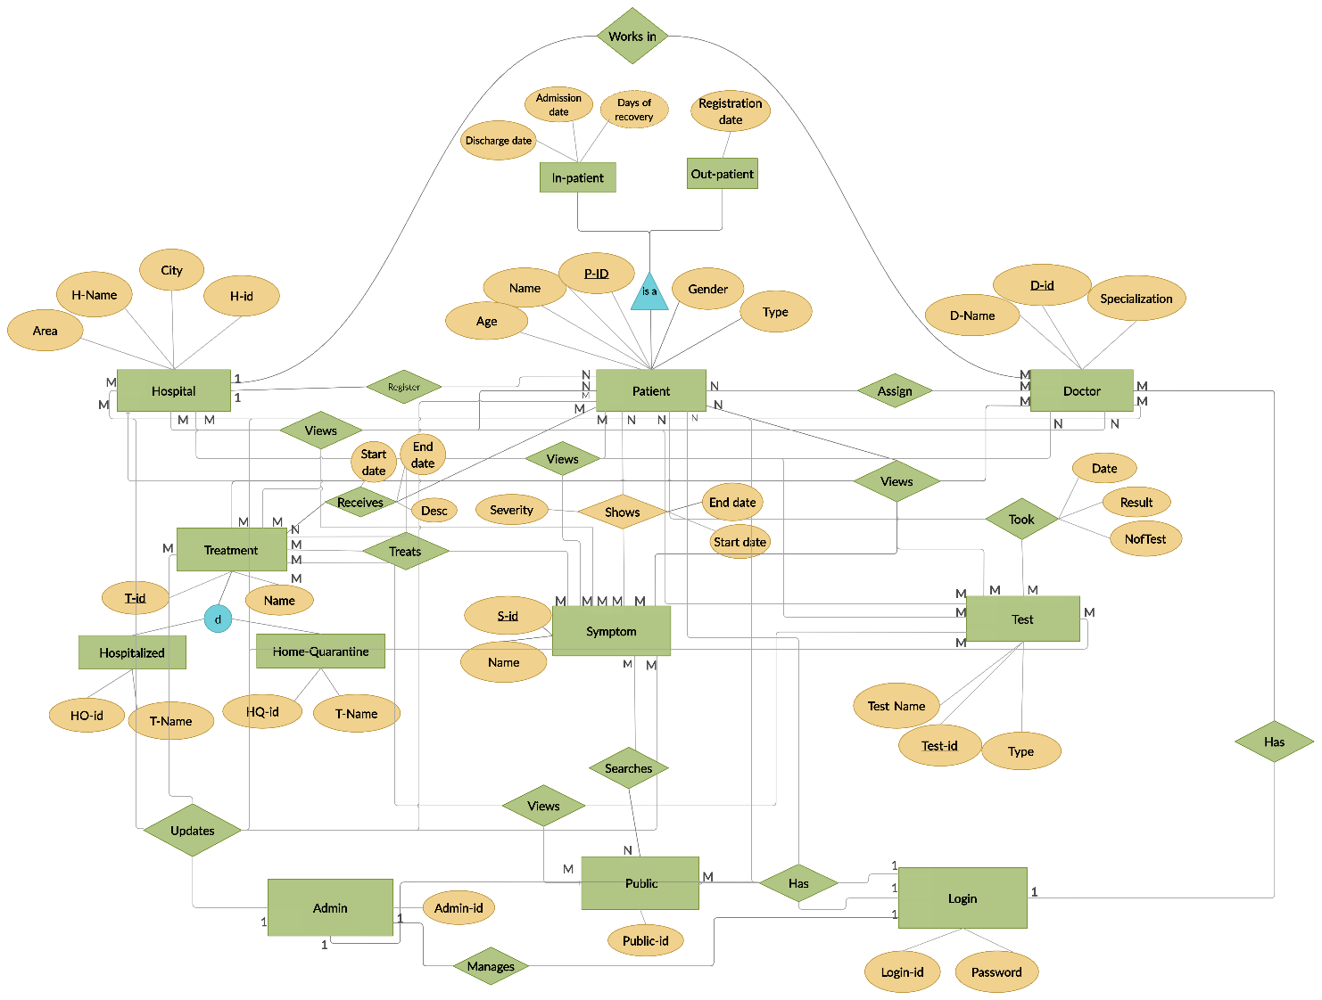

**Entities and their relationships :**

|  |  |  |  |
| --- | --- | --- | --- |
| **Entity** | **Relation** | **Entity** | **Type of relation** |
| Patient | Is assigned | Doctor | Many to Many |
| Patient | Is registered | Hospital | Many to one |
| Patient | shows | Symptoms | Many to Many |
| Patient | took | Test | Many to Many |
| Doctor | Works in | Hospital | Many to one |
| Treatment | Treats | Symptoms | Many to Many |
| Public | has | Login | Many to one |
| Patient | has | Login | Many to one |
| Doctor | has | Login | Many to one |
| Admin | has | Login | One to one |
| Hospital | has | Login | Many to one |
| Admin | updates | Doctor | One to Many |
| Admin | updates | Patient | One to Many |
| Admin | updates | Hospital | One to Many |
| Admin | updates | Symptoms | One to Many |
| Admin | updates | Test | One to Many |
| Admin | updates | Treatment | One to Many |
| Admin | manages | Login | One to one |
| Patient | views | Symptoms | Many to Many |
| Patient | views | Treatment | Many to Many |
| Patient | views | Doctor | Many to Many |
| Patient | views | Hospital | Many to Many |
| Doctor | views | Hospital | Many to Many |
| Doctor | views | Patient | Many to Many |
| Doctor | views | Test | Many to Many |
| Doctor | views | Symptoms | Many to Many |
| Doctor | views | Treatment | Many to Many |
| Hospital | views | Doctor | Many to Many |
| Hospital | views | Patient | Many to Many |
| Hospital | views | Treatment | Many to Many |
| Hospital | views | Symptoms | Many to Many |
| Hospital | views | Test | Many to Many |
| Public | searches | Symptoms | Many to Many |
| Public | views | Treatment | Many to Many |
| Public | views | Test | Many to Many |

**Relational Schema**

**Login**

|  |  |  |  |  |
| --- | --- | --- | --- | --- |
| Login-id | Password |  |  |  |

**Admin**

|  |  |  |  |  |
| --- | --- | --- | --- | --- |
| Admin-id | *Login-id* |  |  |  |

**Hospital**

|  |  |  |  |  |
| --- | --- | --- | --- | --- |
| H-id | H-Name | City | Area | *Login-id* |

**Doctor**

|  |  |  |  |  |
| --- | --- | --- | --- | --- |
| D-id | D-Name | Specialization | *H-ID* | *Login ID* |

**Treatment**

|  |  |  |  |  |
| --- | --- | --- | --- | --- |
| T-id | Name |  |  |  |

**Hospitalized**

|  |  |  |  |
| --- | --- | --- | --- |
| HO-id | T-name | T-id |  |

**Home-Quarantined**

|  |  |  |  |
| --- | --- | --- | --- |
| HQ-id | T-name | T-id |  |

**Symptoms**

|  |  |  |  |
| --- | --- | --- | --- |
| *S-id* | *Name* |  |  |

**Patient**

|  |  |  |  |  |  |
| --- | --- | --- | --- | --- | --- |
| P-id | Name | Age | Gender | Type | *Login-id* |
| *H-id* |  |  |  |  |  |

**In-Patient**

|  |  |  |  |
| --- | --- | --- | --- |
| P-id | Admission date | Discharge date |  |

**Out-Patient**

|  |  |  |
| --- | --- | --- |
| P-id | Registration date |  |

**Shows**

|  |  |  |  |
| --- | --- | --- | --- |
| Show-id | Severity | *P-Id* | *S-Id* |

**Treats**

|  |  |  |  |
| --- | --- | --- | --- |
| Treat-id | *T-id* | *HO-id* | *HQ-id* |
| *S-id* |  |  |  |

**Receives**

|  |  |  |  |  |
| --- | --- | --- | --- | --- |
| Receive-id | Desc | *Treat-id* | *P-id* | *T-id* |

**Assign**

|  |  |  |  |
| --- | --- | --- | --- |
| Assign-id | *P-id* | *D-id* |  |

**Test**

|  |  |  |  |  |
| --- | --- | --- | --- | --- |
| Test-id | Types | Test-Name |  |  |

**Took**

|  |  |  |  |  |
| --- | --- | --- | --- | --- |
| Took-id | Result | Date | *P-id* | *Test-id* |

**Public**

|  |  |  |
| --- | --- | --- |
| Public-id | *Login-id* |  |

**CODD’S RULE**

**The following rules are applicable for our project-**

|  |  |
| --- | --- |
| **RULE** | **APPLICABILITY** |
| Rule 1: Information Rule | This rule is applicable, as everything in the database is stored in a table format. |
| Rule 3: Systematic treatment of NULL | This rule is applicable, as in the given database a null value is treated as data not applicable. |
| Rule 5: Powerful and Well-Structured Language | This rule is applicable, as data is accessed from the given database only using SQL Language. |
| Rule 7: High-Level Insert, Update, and Delete Rule | This rule is applicable as the database will allow all kinds of operations. |
| Rule 12: Non-Subversion Rule | This rule is applicable, as in the given database, updation and viewing rights are strictly specified. |

**Description of tables**

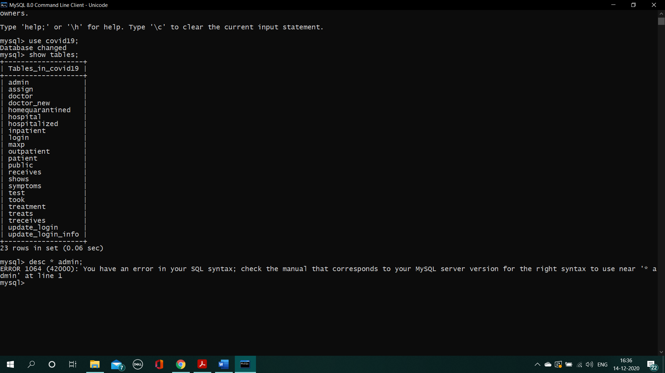

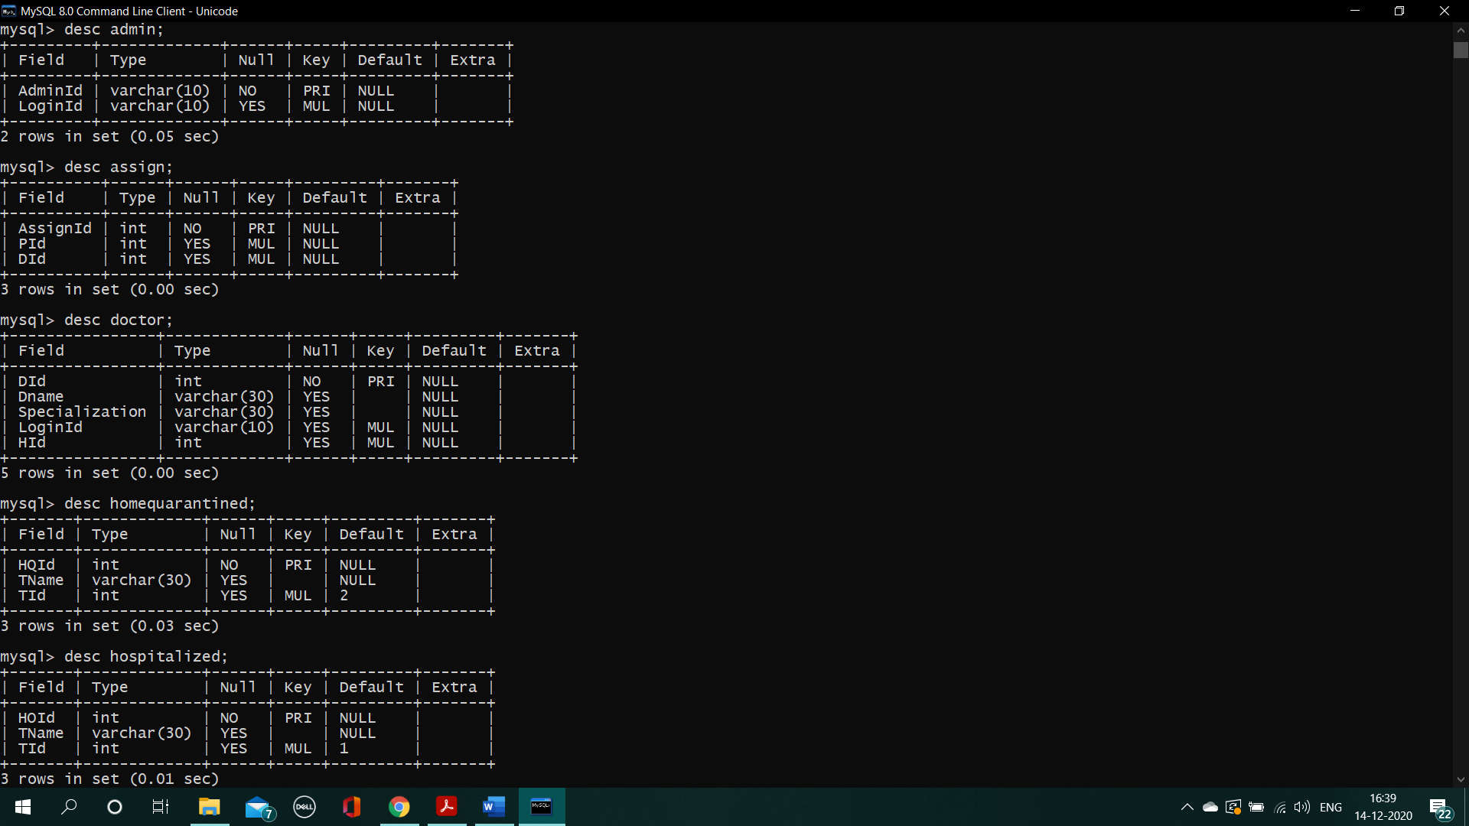

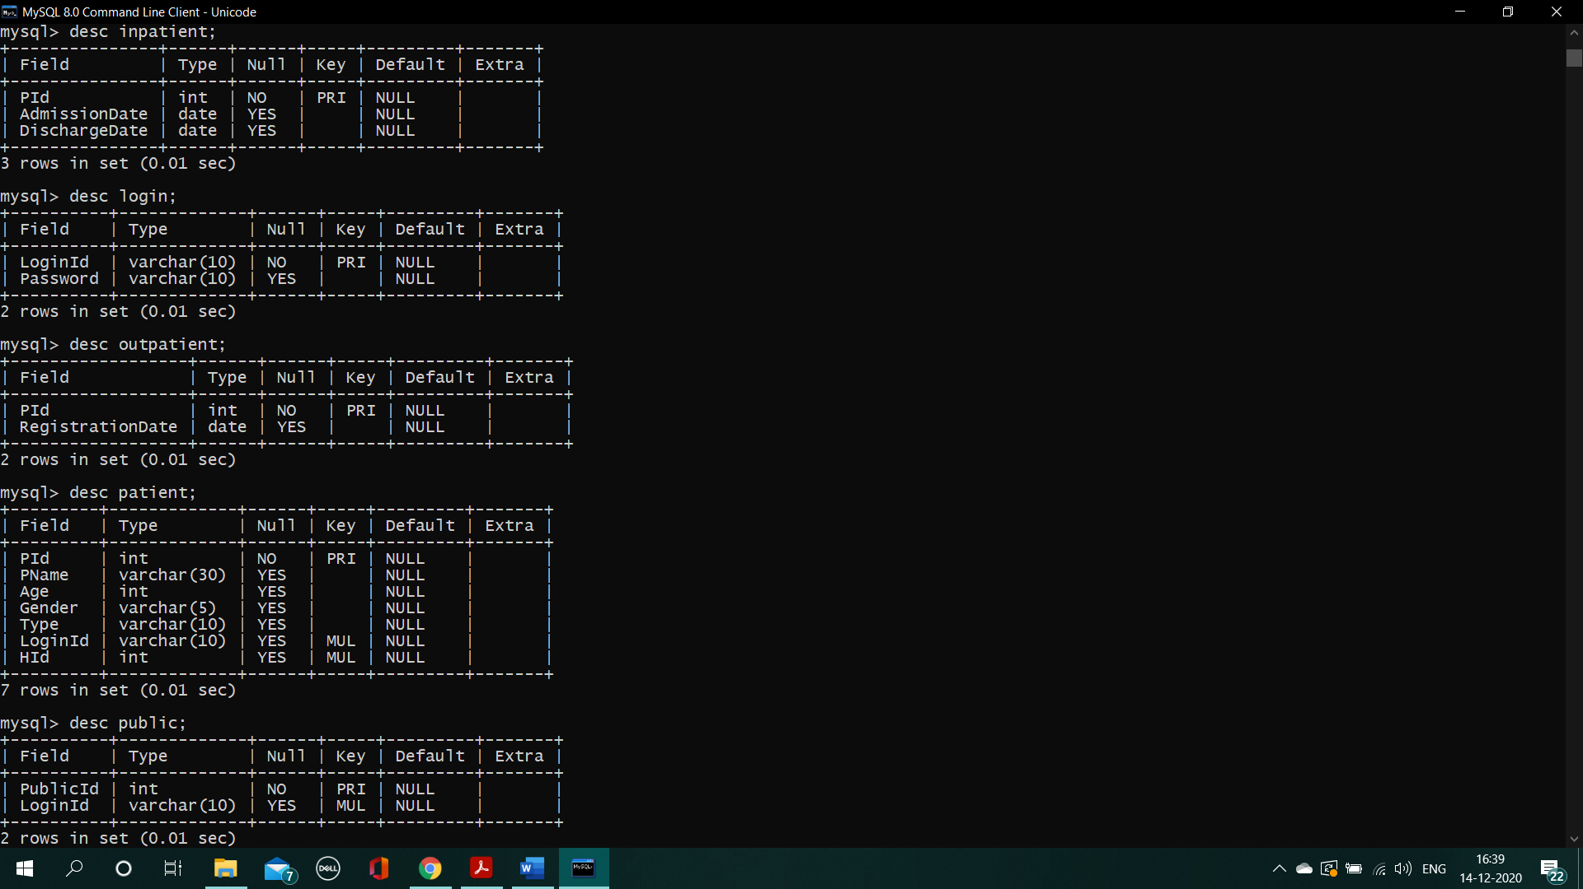

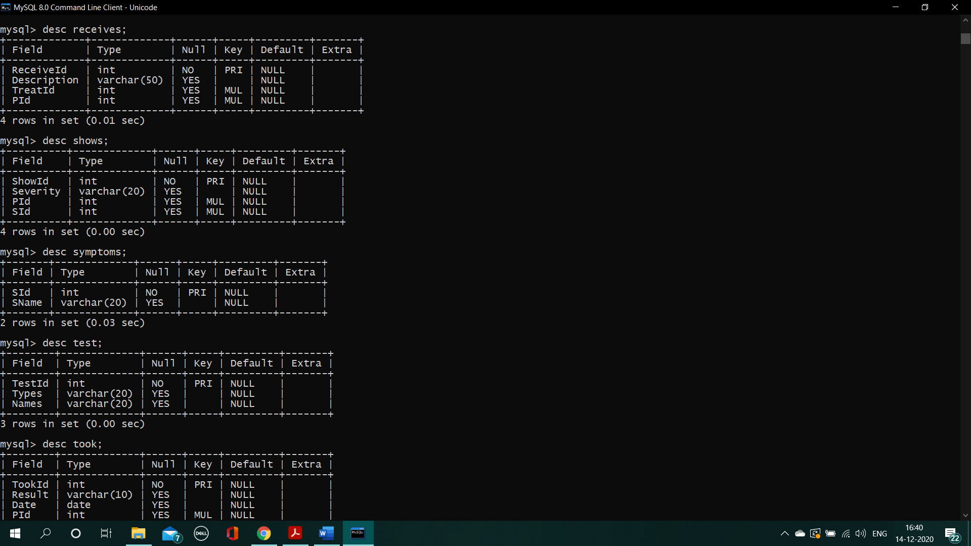

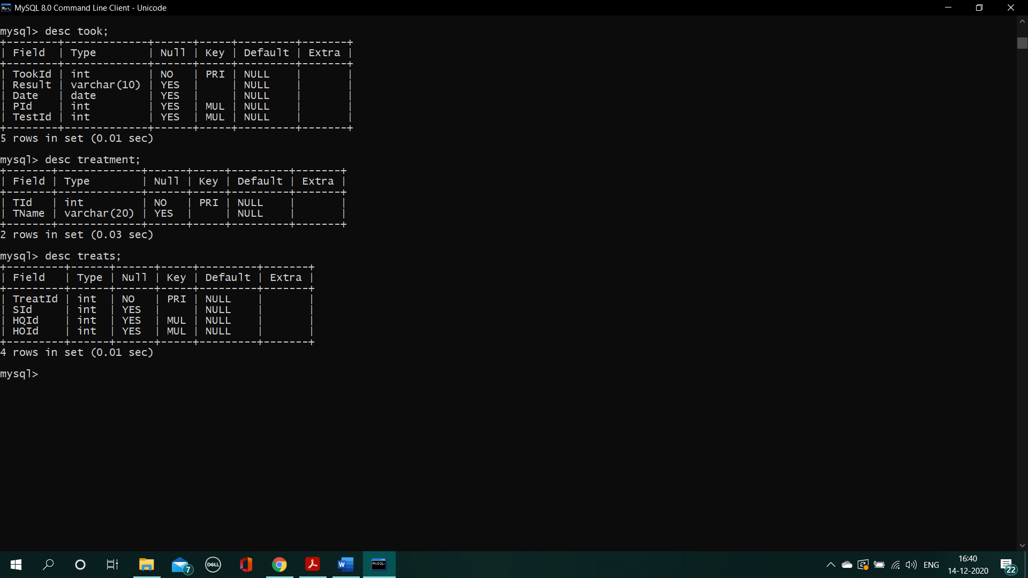

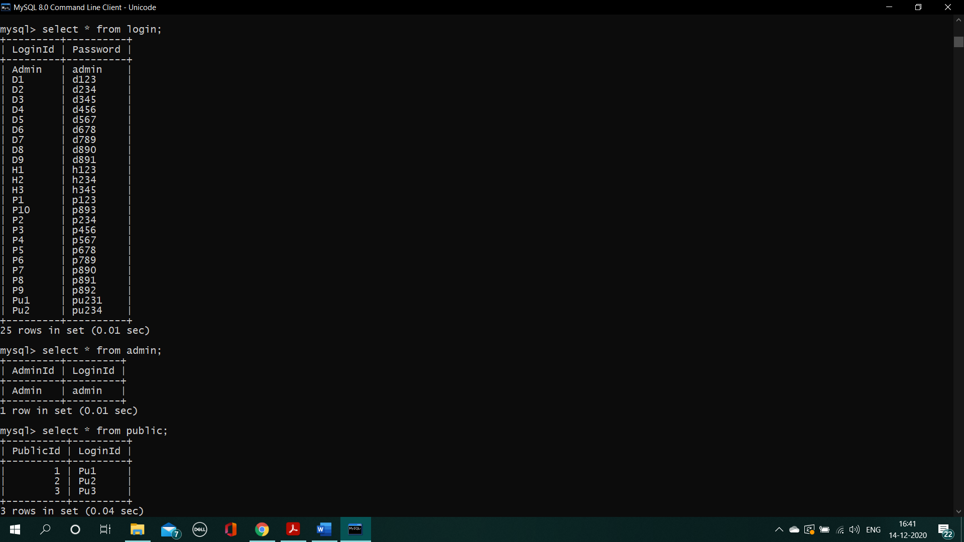

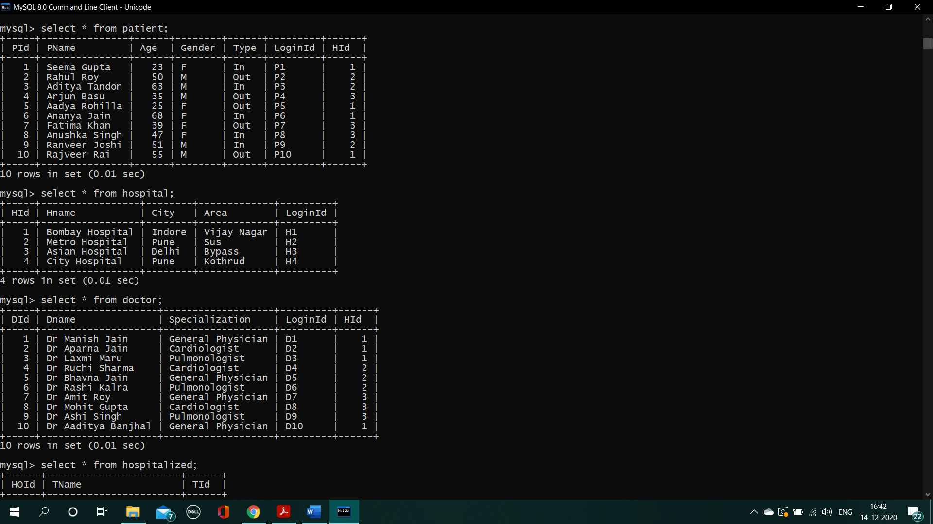

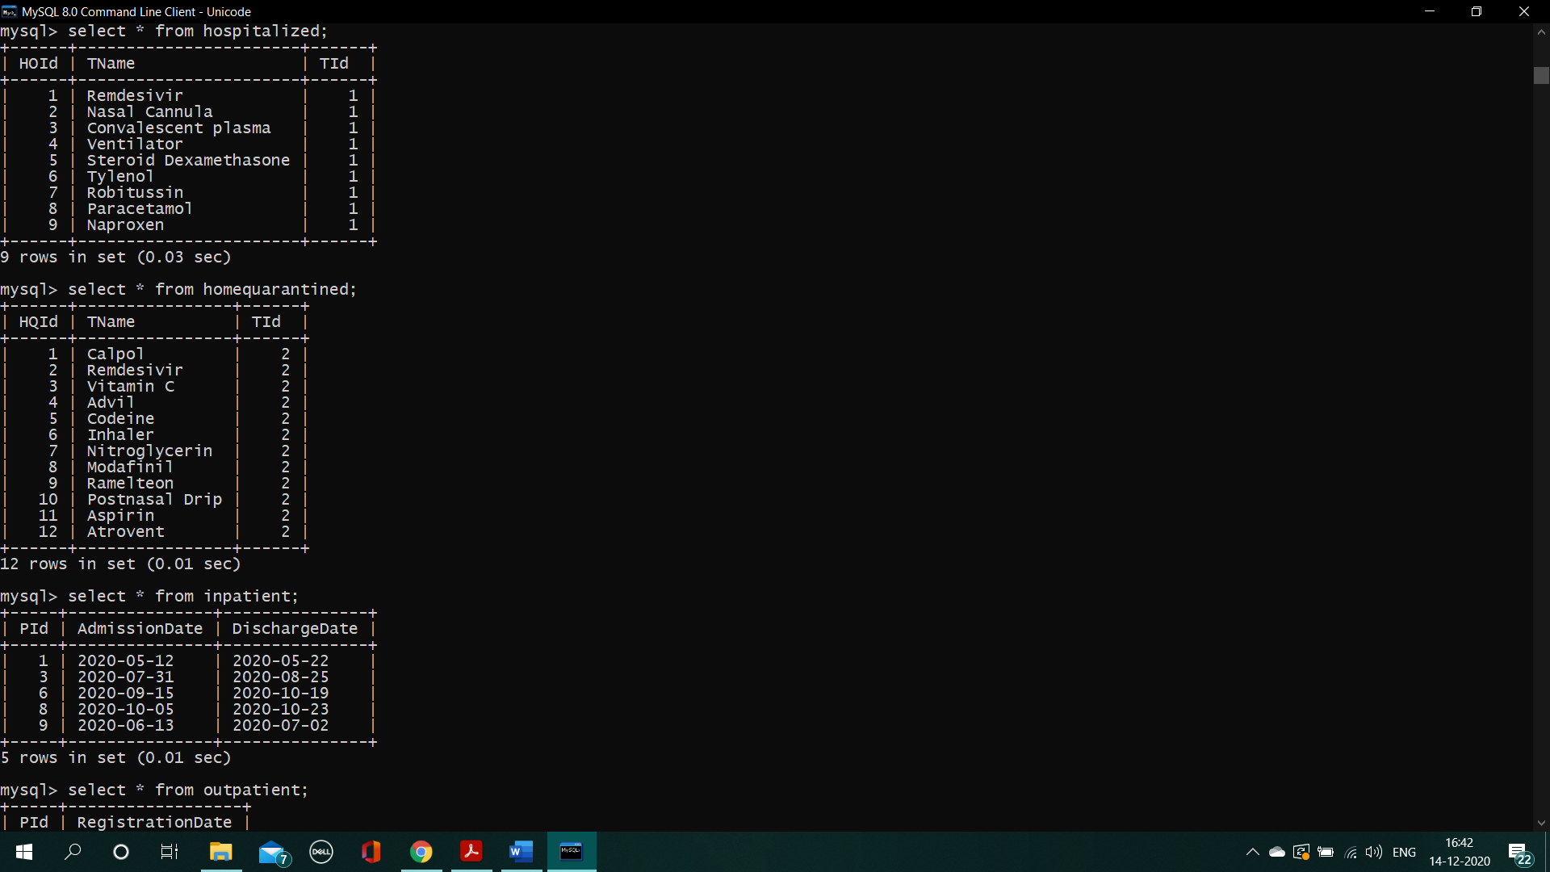

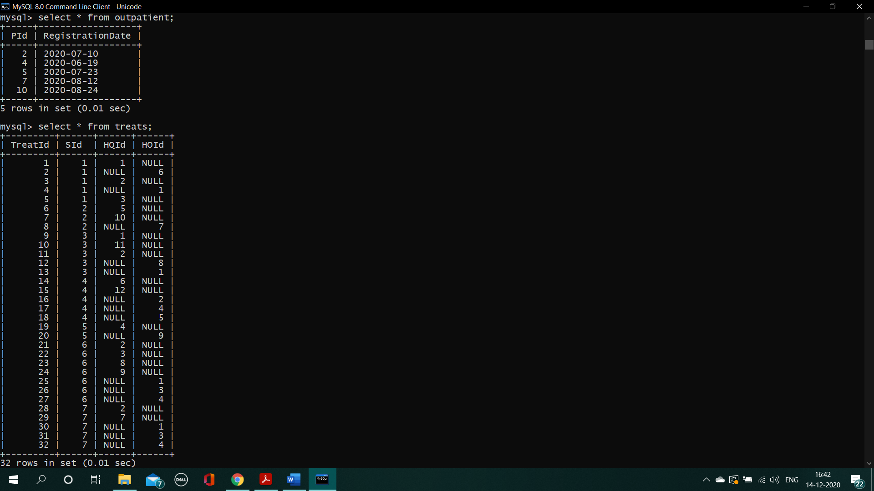

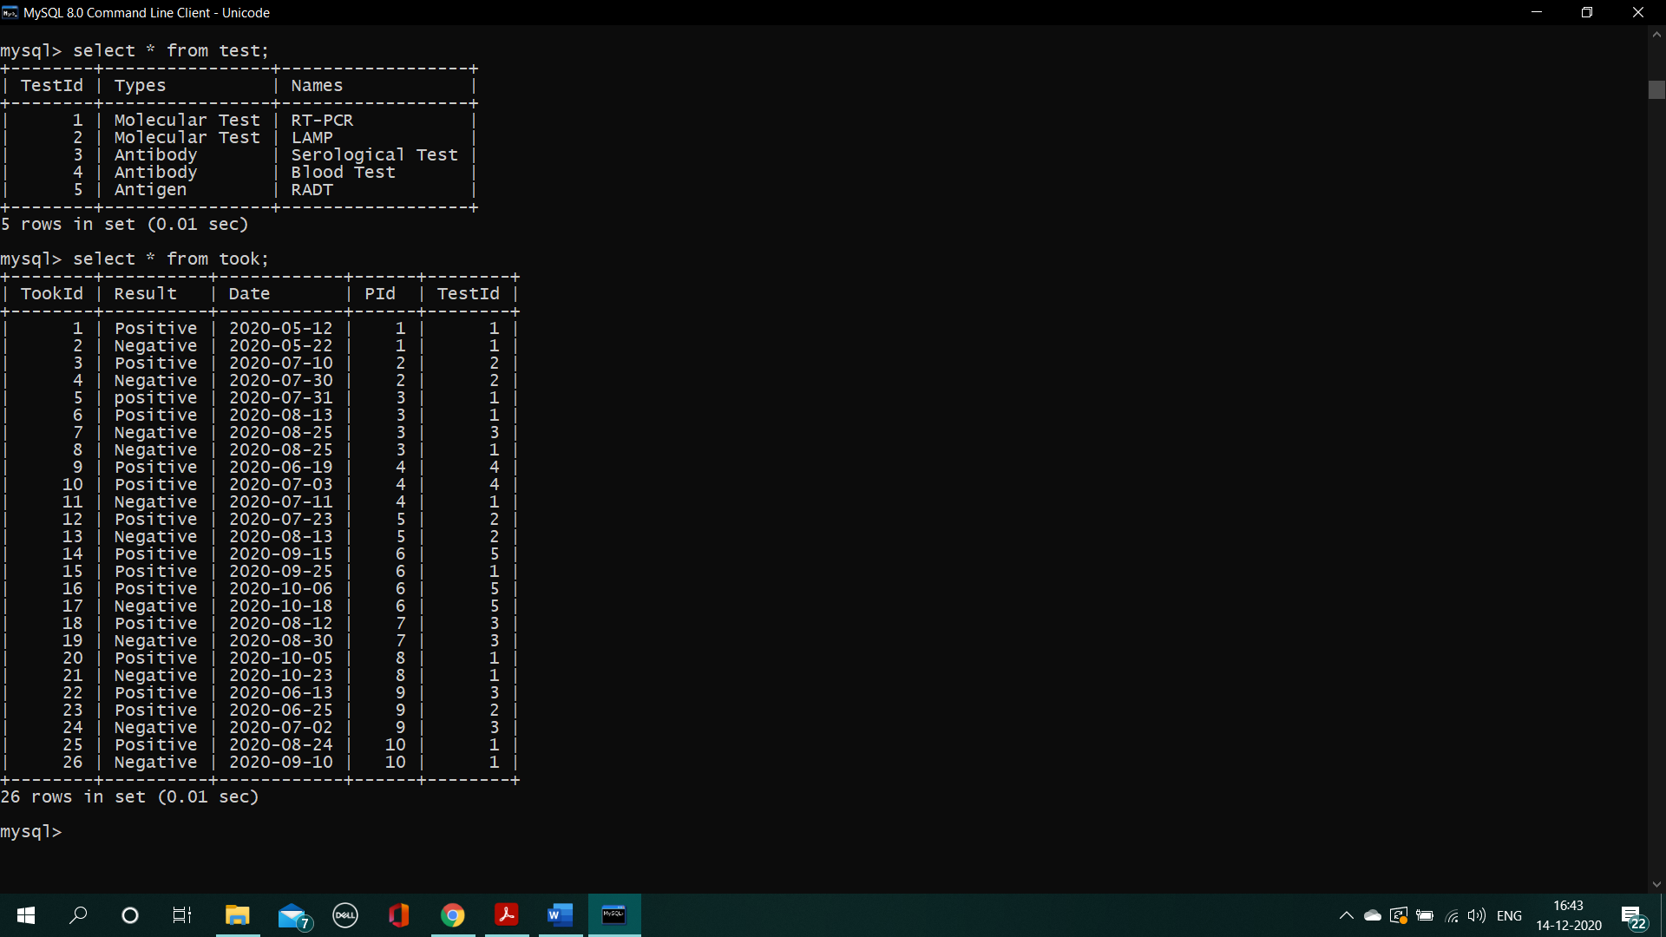

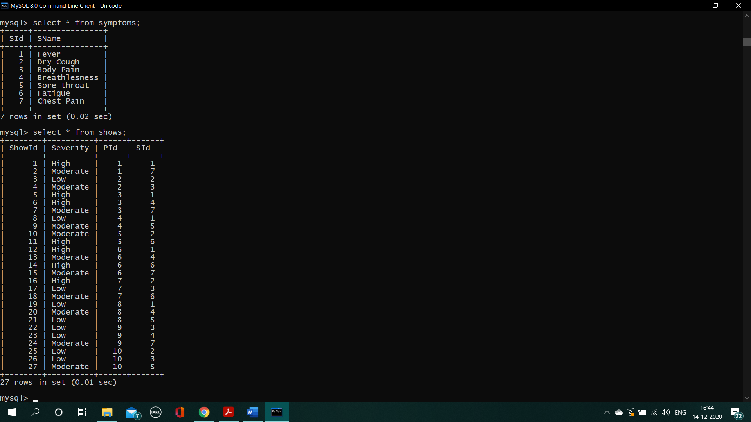

**Functional Dependencies-**

**Login-**

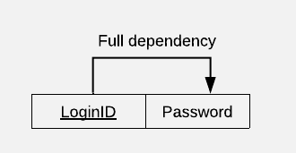

**Admin-**

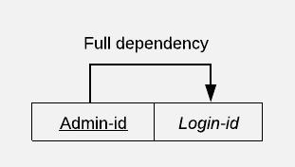

**Hospital-**

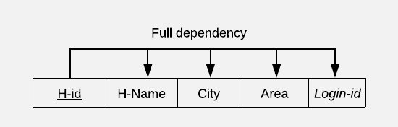

**Doctor-**

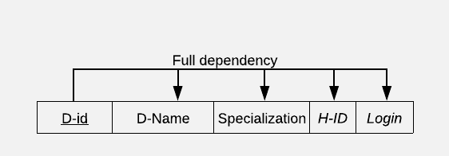

**Treatment-**

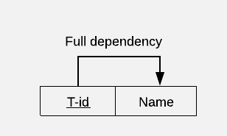

**Hospitalized-**

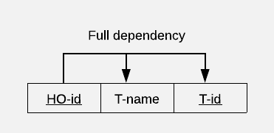

**Home-Quarantined-**

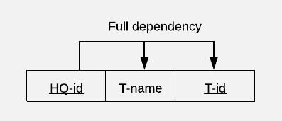

**Symptoms-**

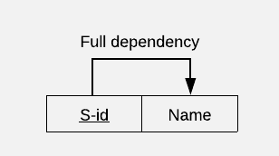

**Patient-**

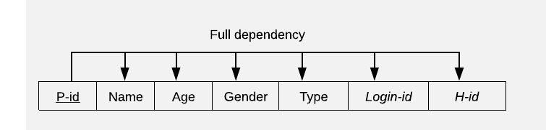

**In-Patient-**

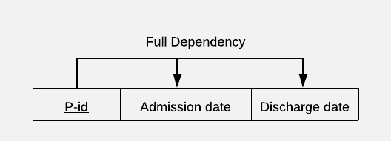

**Out-Patient-**

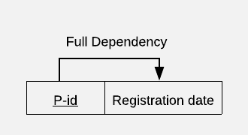

**Shows-**

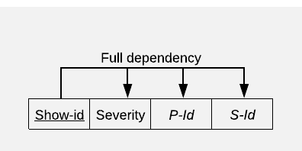

**Treats-**

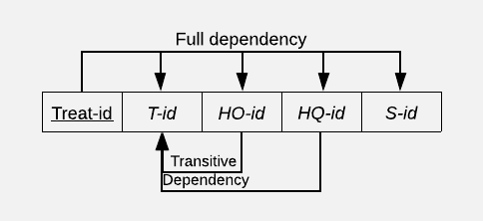

**Receives-**

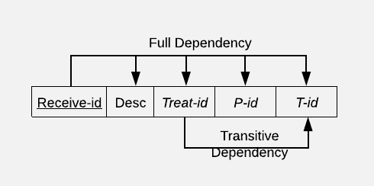

**Assign-**

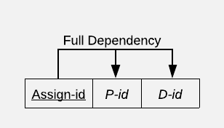

**Test-**

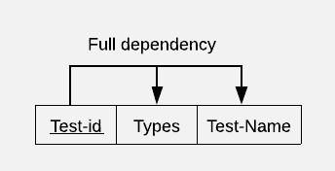

**Took-**

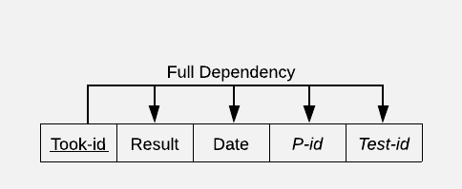

**Public-**

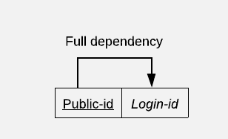

**FUNCTIONAL DEPENDENCY CHARTS** 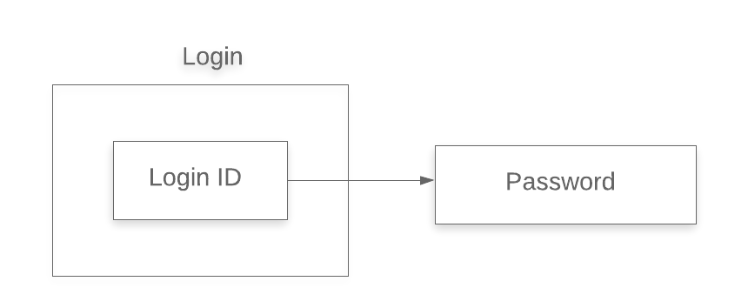

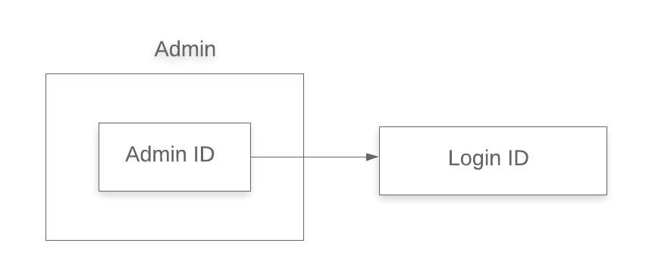

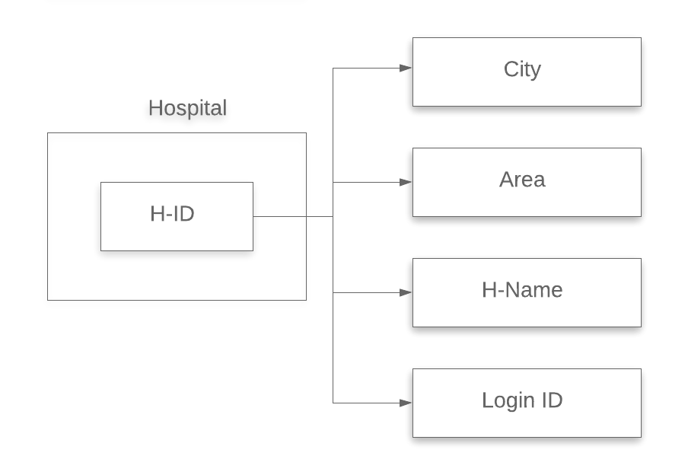

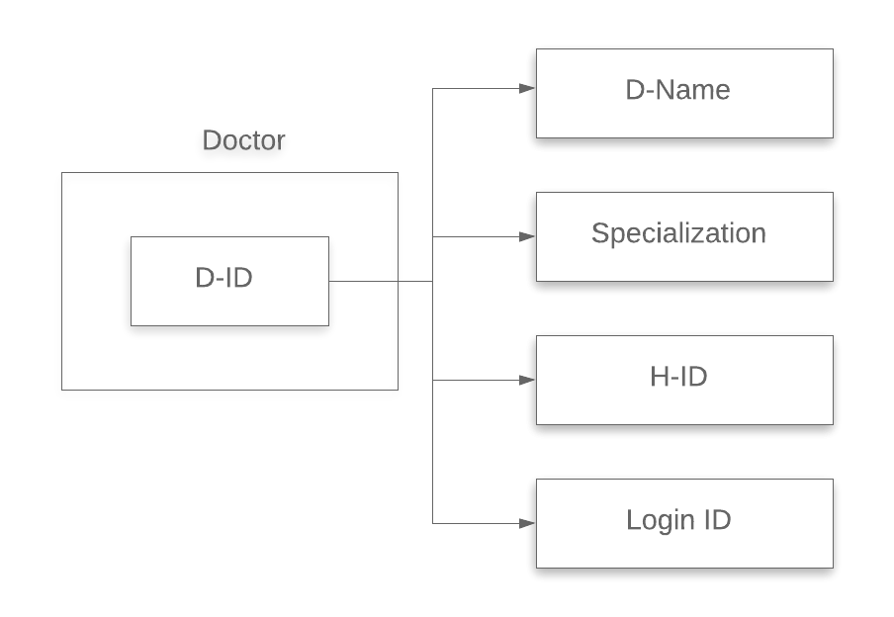

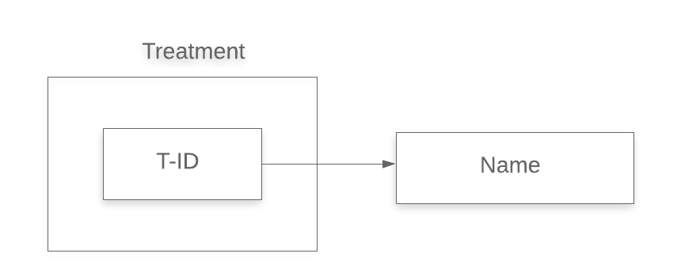

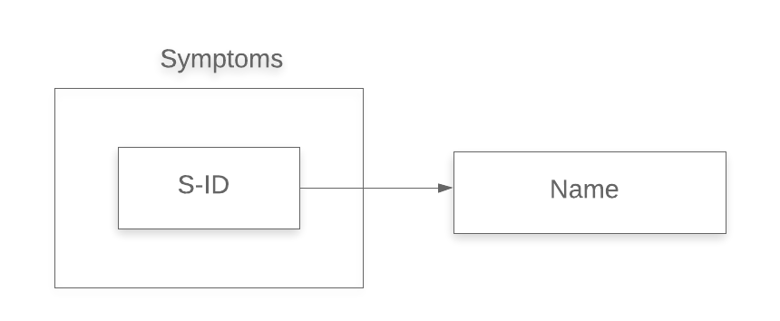

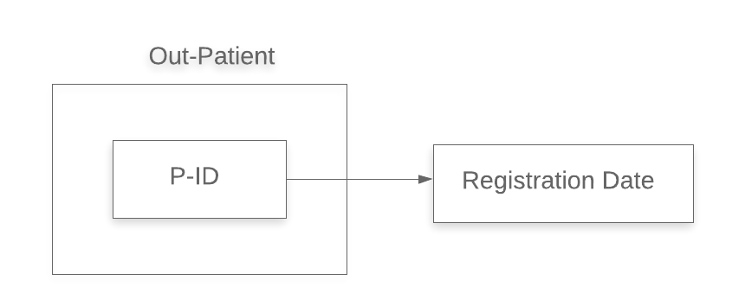

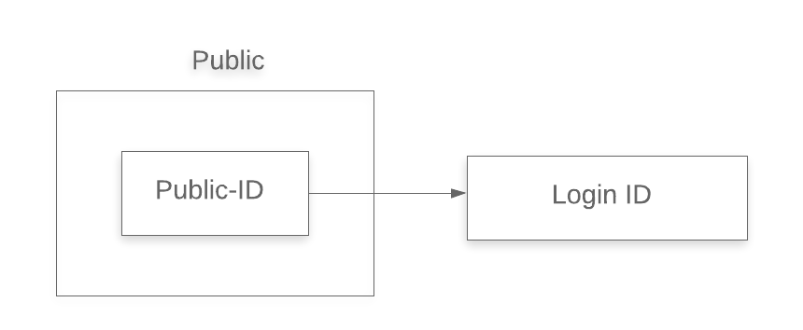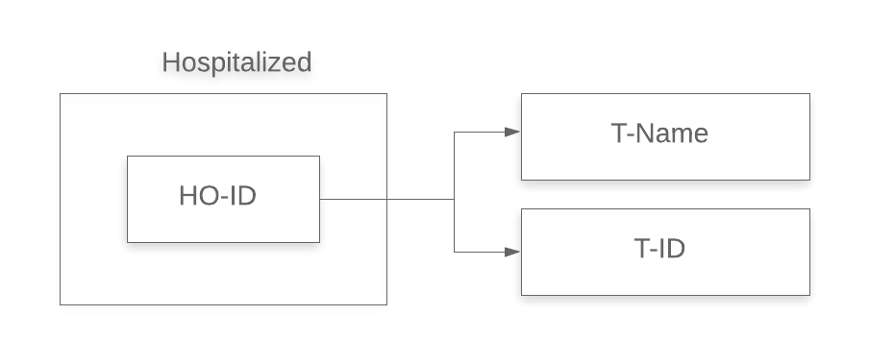

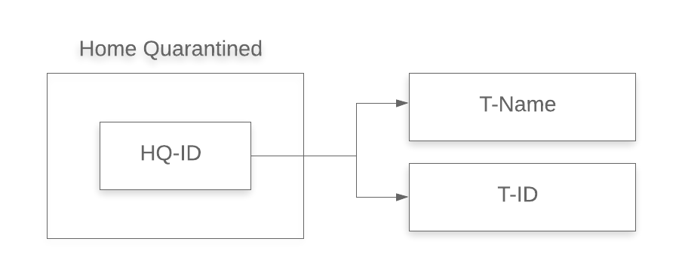

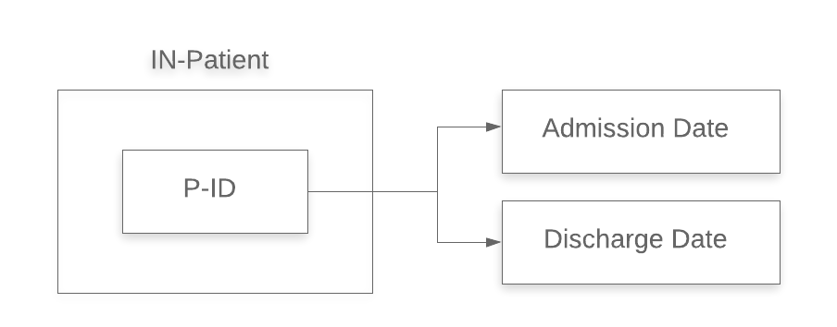

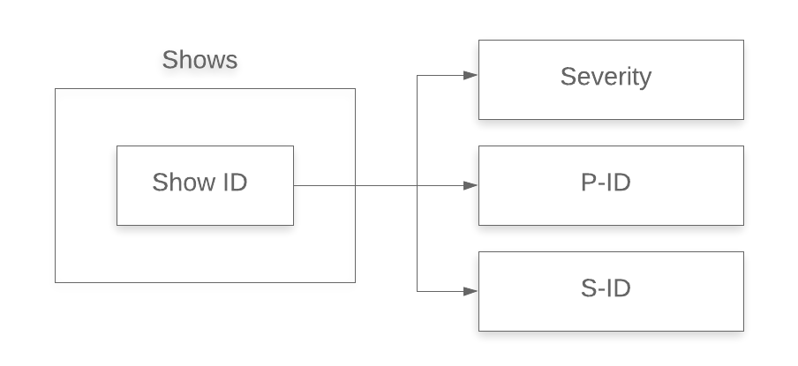

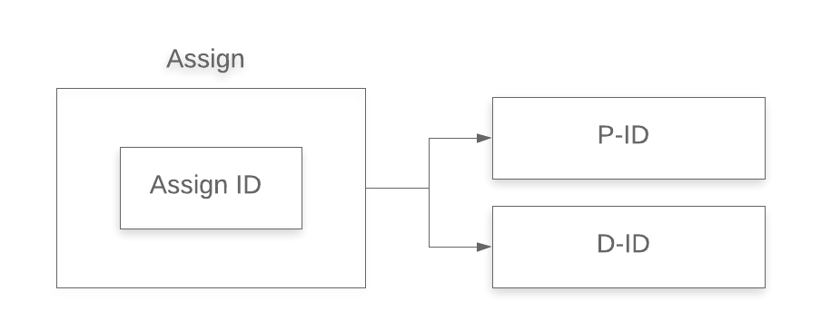

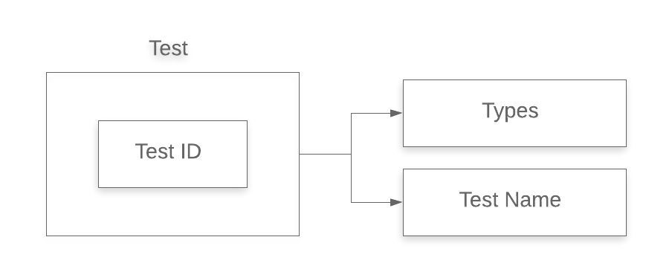

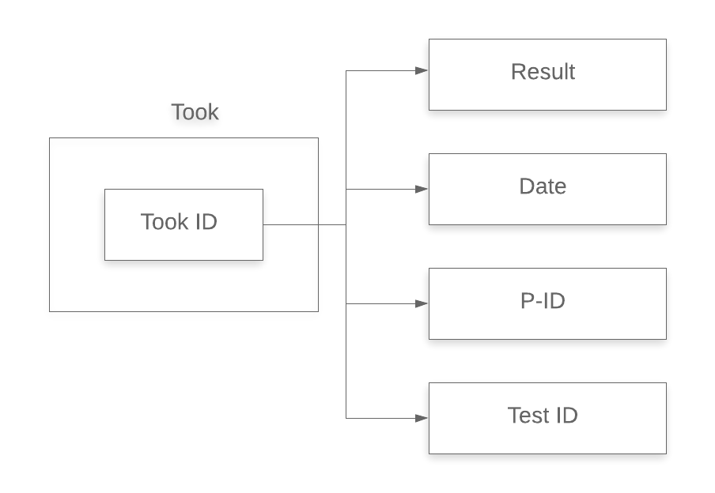

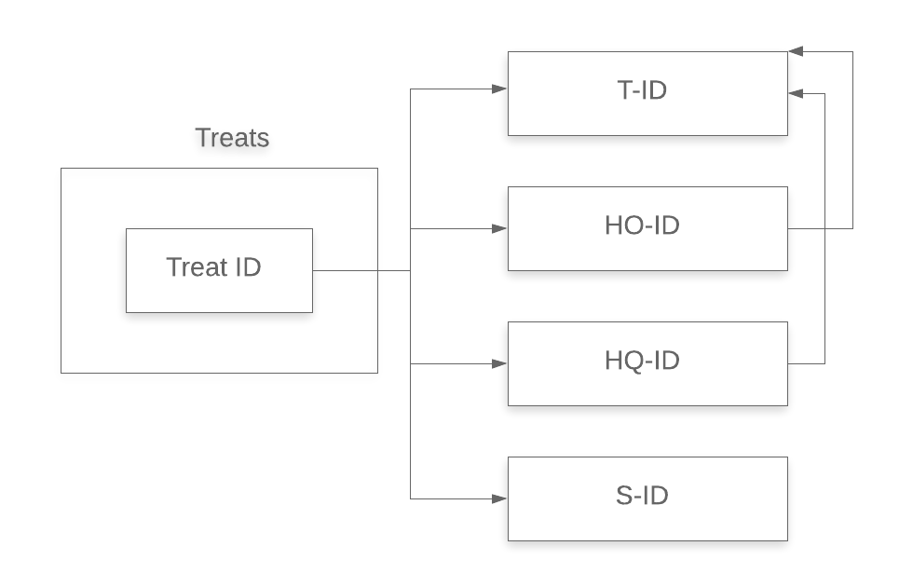

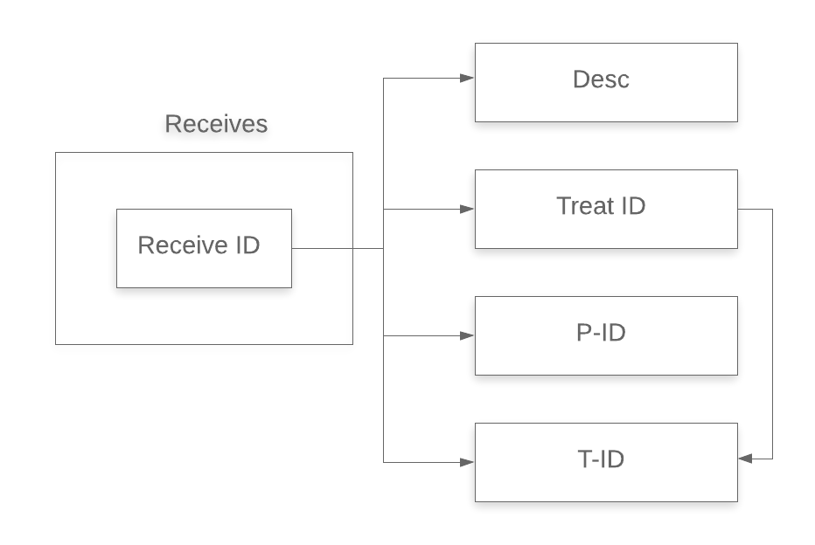

**Anomalies-**

After analyzing each and every table, we have come to a conclusion that there are no anomalies in the database.

**Normalization-**

Upon analyzing the database, we have found that it is already in 2NF form.

**2NF 🡪 3NF**

Removing transitive dependencies –

**Treats**



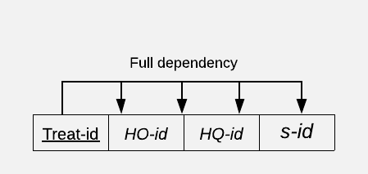

There already exists two tables (Home Quarantined, Hospitalized) having relations between T-id, HO-id and HQ-id.

**Receives**



**Receives**

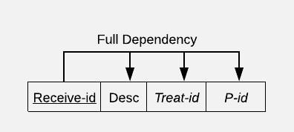

**T-Receives** 

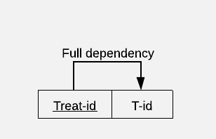

**3NF 🡪 BCNF**

Coming to **BCNF**, the database is already in this form as all the determinants are candidate keys and is in 3NF form.

____________________________________________

**Queries**

1. **List of doctors working for hospital in city Pune.**

-> select dname as 'Doctors Working in Pune' from doctor where hid in (select hid from hospital where city='Pune');

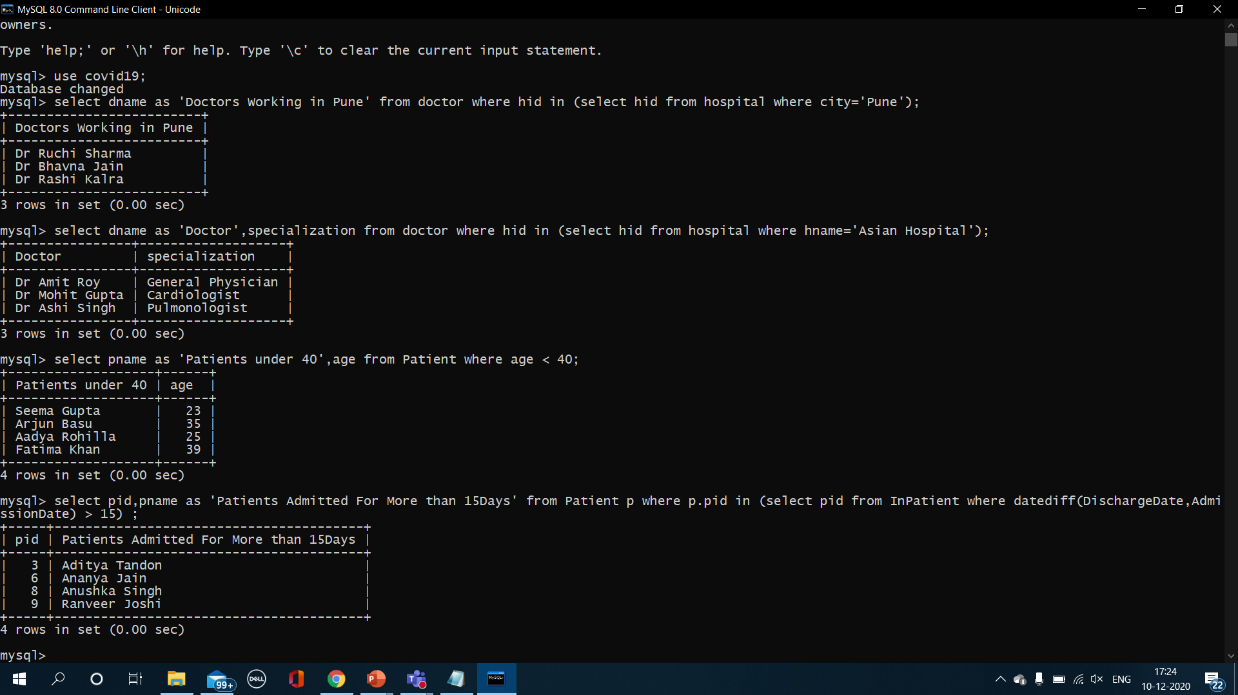

**2. List of Specializations of doctors for hospital Asian.**

-> select dname as 'Doctor',specialization from doctor where hid in (select hid from hospital where hname='Asian Hospital');



**3. List of all the patients under the age of 40.**

-> select pname as 'Patients under 40',age from Patient where age < 40;



**4. List of Patients admitted for more than 15 days.**

-> select pid,pname as 'Patients Admitted For More than 15Days' from Patient p where p.pid in (select pid from InPatient where datediff(DischargeDate,AdmissionDate) > 15) ;



**5. Find the treatment for Symptom “Sore throat”.**

-> select tname as 'Treatment for Sore Throat' from hospitalized where hoid in (select hoid from treats where sid in (select sid from symptoms where sname='Sore Throat')) UNION select tname as 'Treatment for Sore Throat' from homequarantined where hqid in (select hqid from treats where sid in (select sid from symptoms where sname='Sore Throat'));

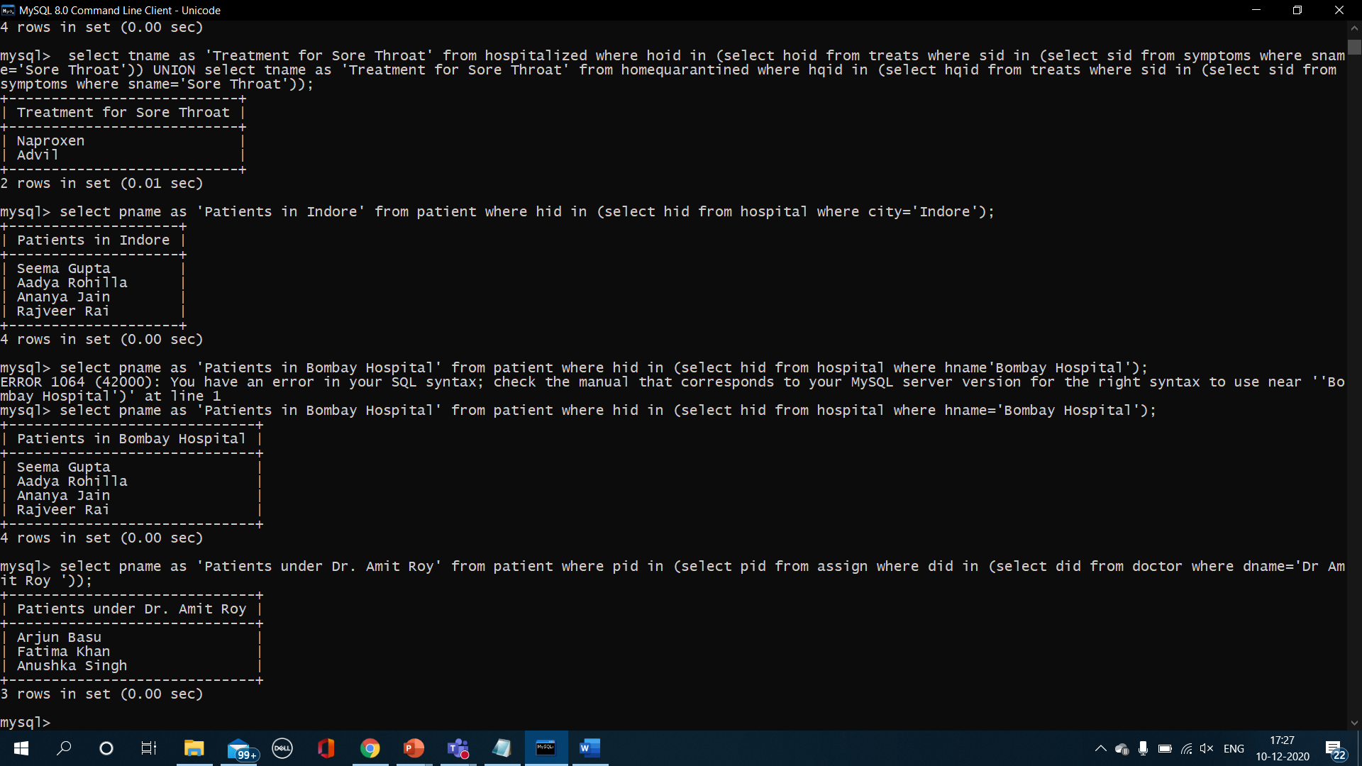

**6. List of Patients in city Indore.**

-> select pname as 'Patients in Indore' from patient where hid in (select hid from hospital where city='Indore');



**7. List of Patients associated with “Bombay Hospital”.**

-> select pname as 'Patients in Bombay Hospital' from patient where hid in (select hid from hospital where hname'Bombay Hospital');



**8. List of all the patients under Doctor “Amit Roy”.**

-> select pname as 'Patients under Dr. Amit Roy' from patient where pid in (select pid from assign where did in (select did from doctor where dname='Dr Amit Roy '));



**9. List of dates when Antibody test was taken.**

-> select date as 'Dates of Antibody Test' from took where testid in (select testid from test where types='Antibody');

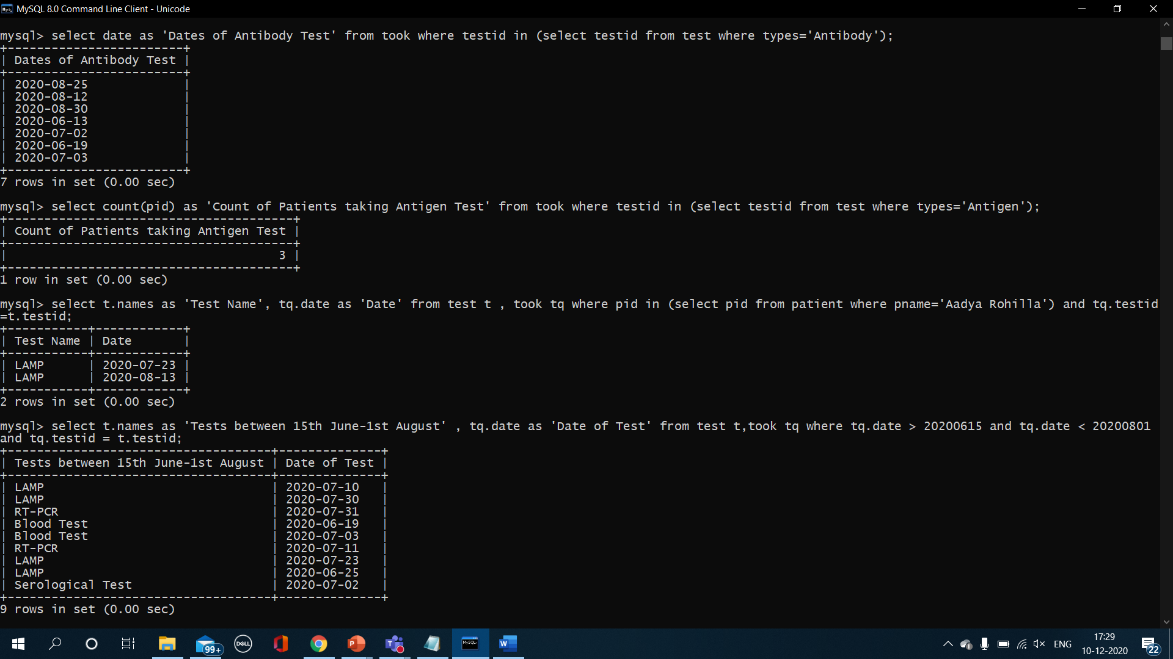

**10. Count of Patients taking Antigen test.**

-> select count(pid) as 'Count of Patients taking Antigen Test' from took where testid in (select testid from test where types='Antigen');

**11. List of Tests along with date when Patient “Aadya Rohilla” took.**

-> select t.names as 'Test Name', tq.date as 'Date' from test t , took tq where pid in (select pid from patient where pname='Aadya Rohilla') and tq.testid=t.testid;



**12. Lists of Tests taken between 2020-06-15 and 2020-08-01.**

-> select t.names as 'Tests between 15th June-1st August' , tq.date as 'Date of Test' from test t,took tq where tq.date > 20200615 and tq.date < 20200801 and tq.testid = t.testid;



**13. List of Patients who show HIGH fever.**

-> select p.pname as 'Patients who show high fever' from patient p, shows s, symptoms sy where s.pid=p.pid and sy.sid=s.sid and s.severity='High' and sy.sname='Fever';

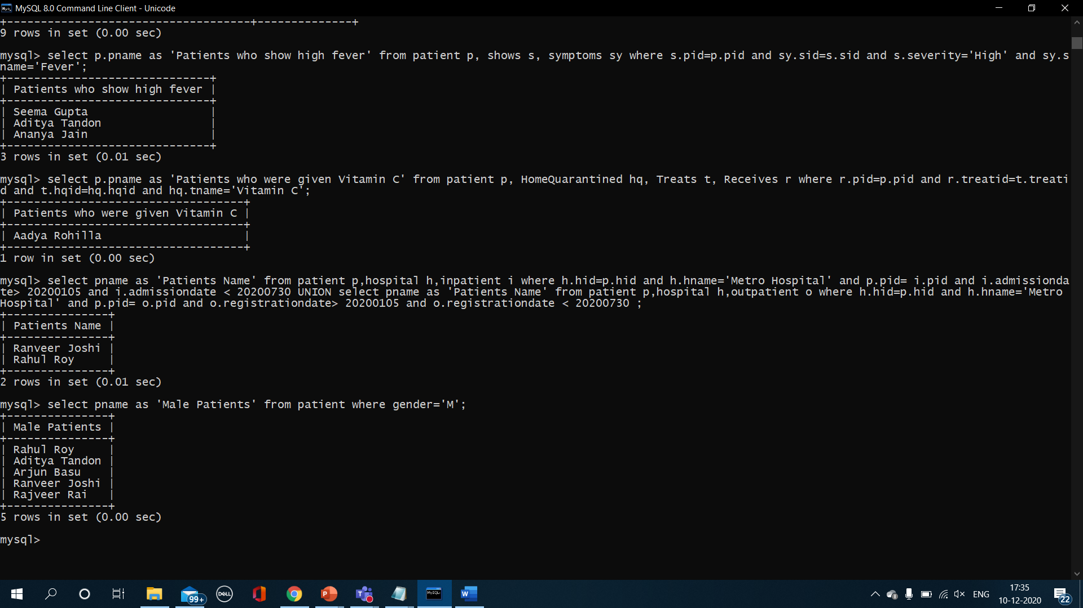

**14. List of Patients who were given Vitamin C.**

-> select p.pname as 'Patients who were given Vitamin C' from patient p, HomeQuarantined hq, Treats t, Receives r where r.pid=p.pid and r.treatid=t.treatid and t.hqid=hq.hqid and hq.tname='Vitamin C';



**15. List of Patients admitted to Hospital Metro between 1st May and 3oth July.**

-> select pname as 'Patients Name' from patient p,hospital h,inpatient i where h.hid=p.hid and h.hname='Metro Hospital' and p.pid= i.pid and i.admissiondate> 20200105 and i.admissiondate < 20200730 UNION select pname as 'Patients Name' from patient p,hospital h,outpatient o where h.hid=p.hid and h.hname='Metro Hospital' and p.pid= o.pid and o.registrationdate> 20200105 and o.registrationdate < 20200730 ;



**16. List of all the male patients.**

-> select pname as 'Male Patients' from patient where gender='M';



**17. Description for Rajveer.**

-> select description as 'Description for Rajveer' from receives where pid in (select pid from patient where pname='Rajveer Rai');

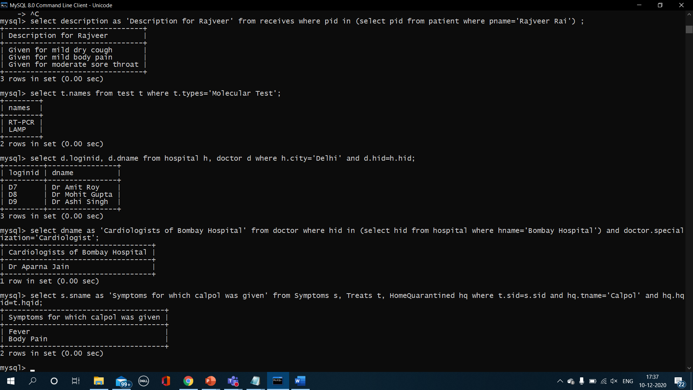

**18. List of All the Molecular test.**

-> select t.names from test t where t.types='Molecular Test';



**19. Login id's of all the doctors working in hospital of city Delhi.**

-> select d.loginid as ‘Login ID of Doctors in Delhi’, d.dname as ‘Doctor Name’ from hospital h, doctor d where h.city='Delhi' and d.hid=h.hid;

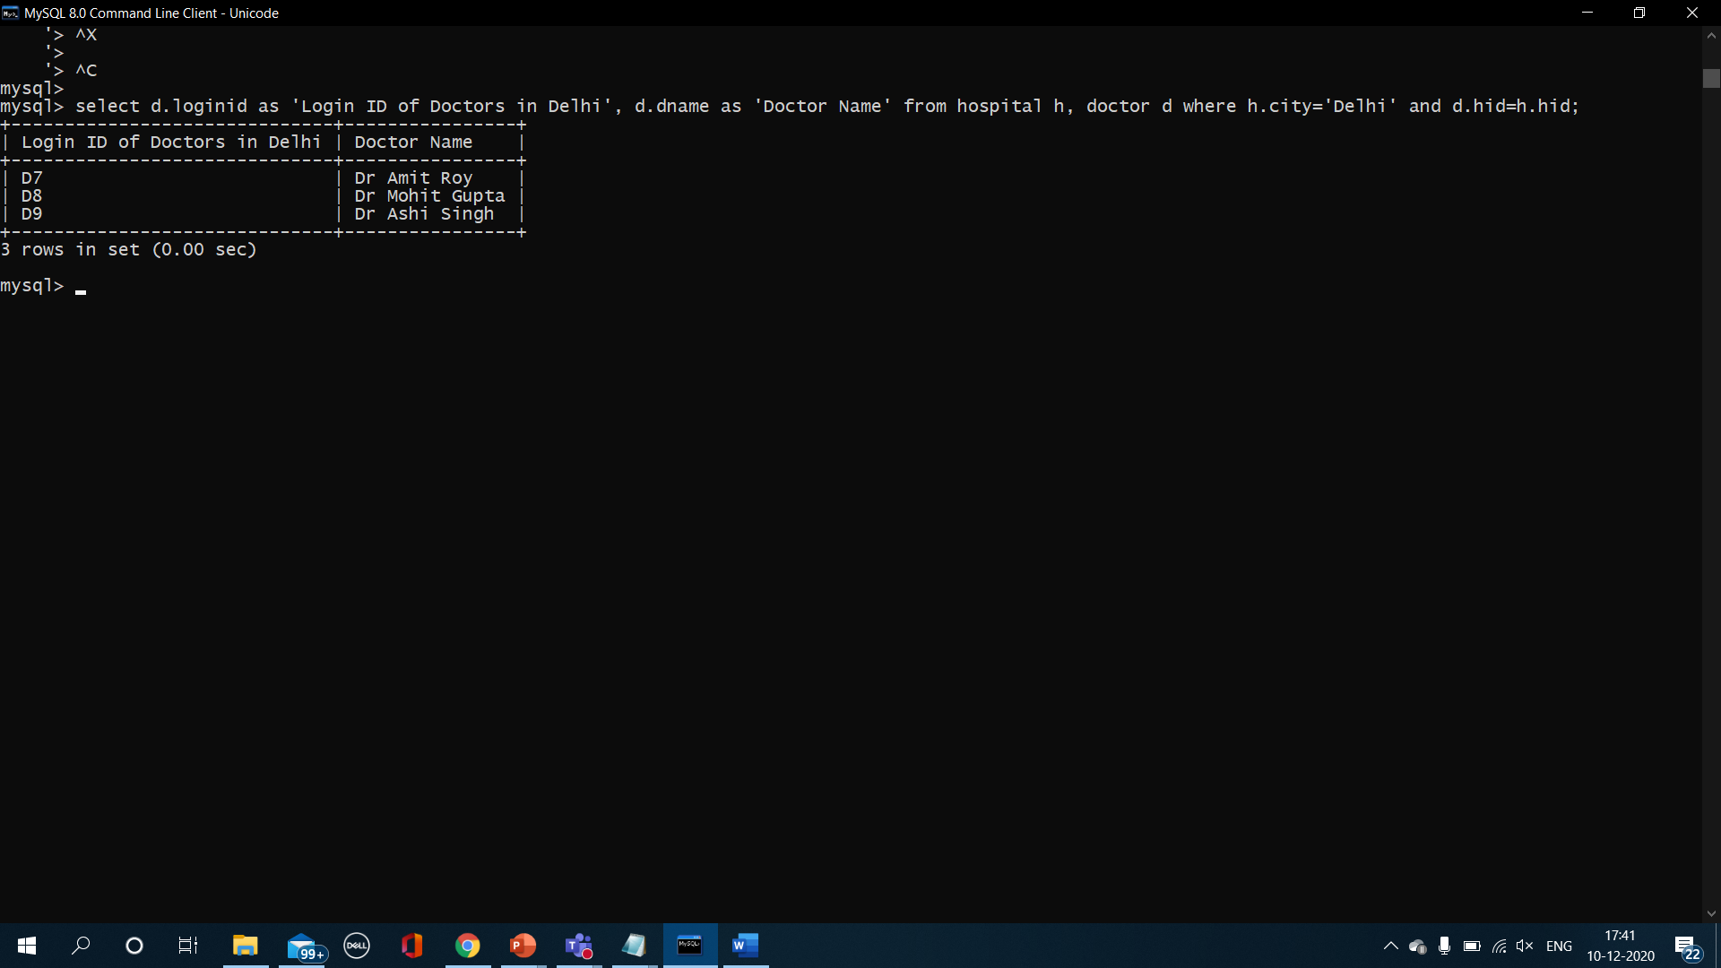

**20. List of doctors with Specialization as “Cardiologist” of “Bombay hospital”.**

-> select dname as 'Cardiologists of Bombay Hospital' from doctor where hid in (select hid from hospital where hname='Bombay Hospital') and doctor.specialization='Cardiologist';



**21. List of Symptoms for which “Calpol” was given.**

-> select s.sname as 'Symptoms for which calpol was given' from Symptoms s, Treats t, HomeQuarantined hq where t.sid=s.sid and hq.tname='Calpol' and hq.hqid=t.hqid;



**22. List of patients tested who 'positve' for the LAMP test.**

-> select p.pname as 'Tested positive for LAMP test' from patient p,took tq,test t where p.pid = tq.pid and tq.result='Positive' and tq.testid=t.testid and t.names='LAMP';

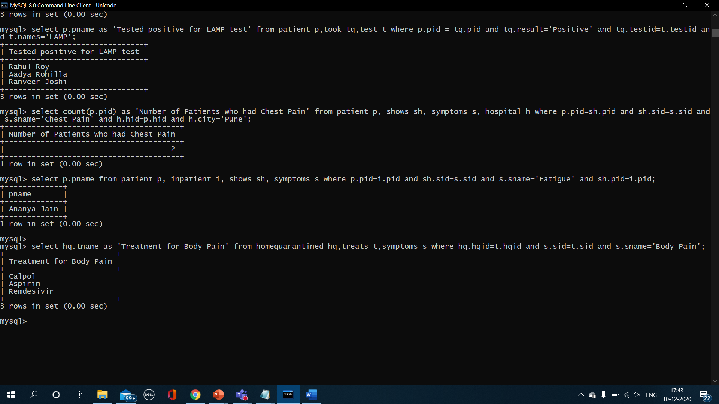

**23. Count of number of patients in city Pune who showed chest pain as a symptom.**

-> select count(p.pid) as 'Number of Patients who had Chest Pain' from patient p, shows sh, symptoms s, hospital h where p.pid=sh.pid and sh.sid=s.sid and s.sname='Chest Pain' and h.hid=p.hid and h.city='Pune';



**24. List of In Patients who show Fatigue as a symptom.**

-> select p.pname from patient p, inpatient i, shows sh, symptoms s where p.pid=i.pid and sh.sid=s.sid and s.sname='Fatigue' and sh.pid=i.pid;



**25. Treatment for home quarantined patient for Symptom - Body Pain.**

-> select hq.tname as 'Treatment for Body Pain' from homequarantined hq,treats t,symptoms s where hq.hqid=t.hqid and s.sid=t.sid and s.sname='Body Pain';



**Functions-**

1. **Ratio of number of IN and OUT patients.**

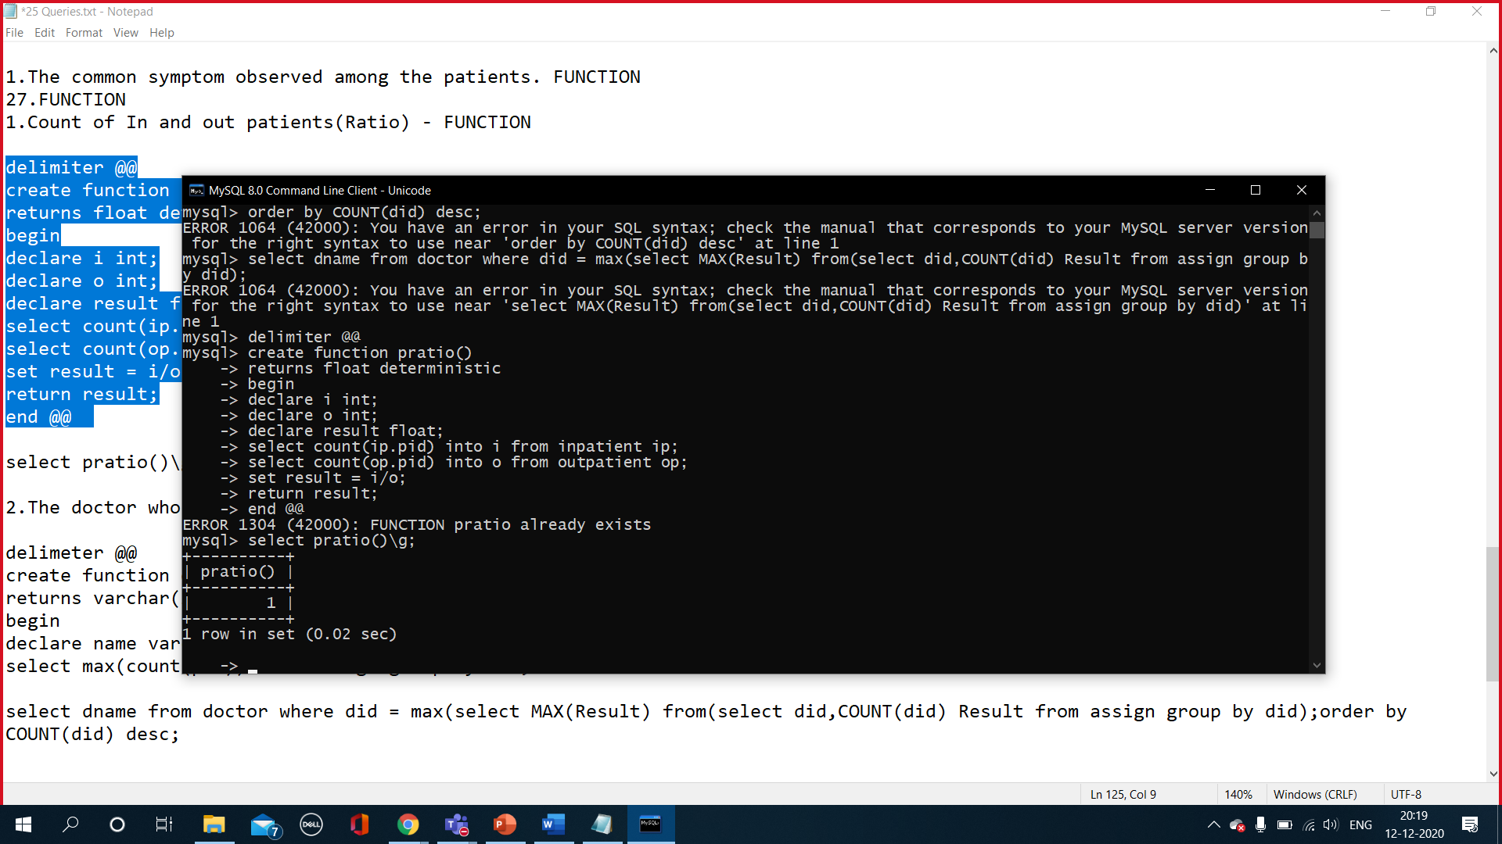

1. **Number of Patients taking the Antigen Test.**

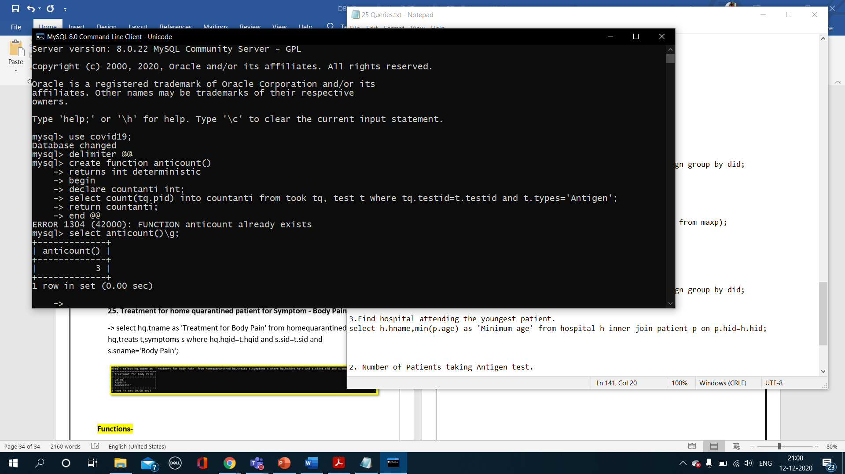

1. **Calculate the average age of Female patients.**

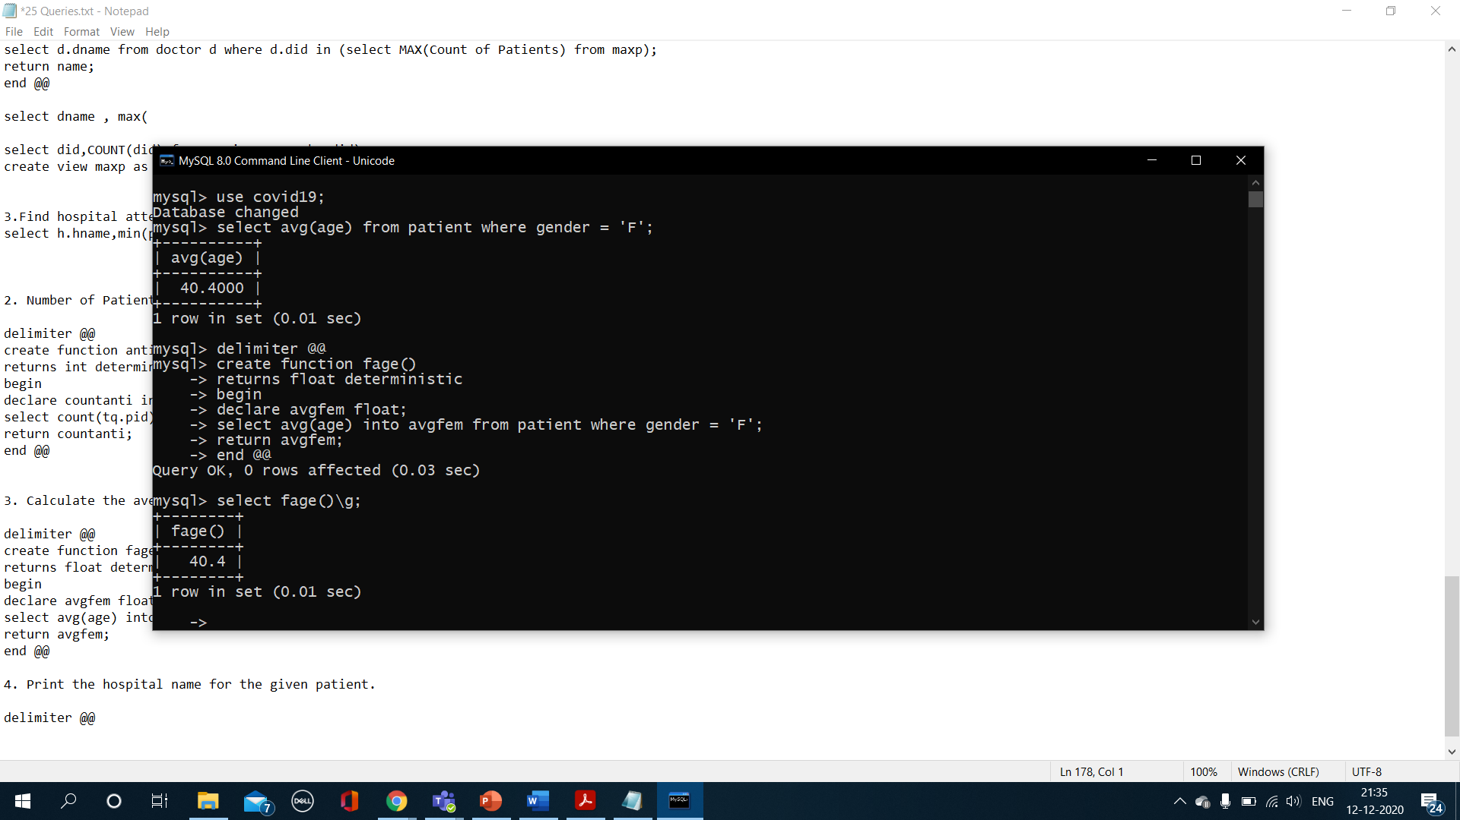

1. **Get the hospital name for the given patient name.**

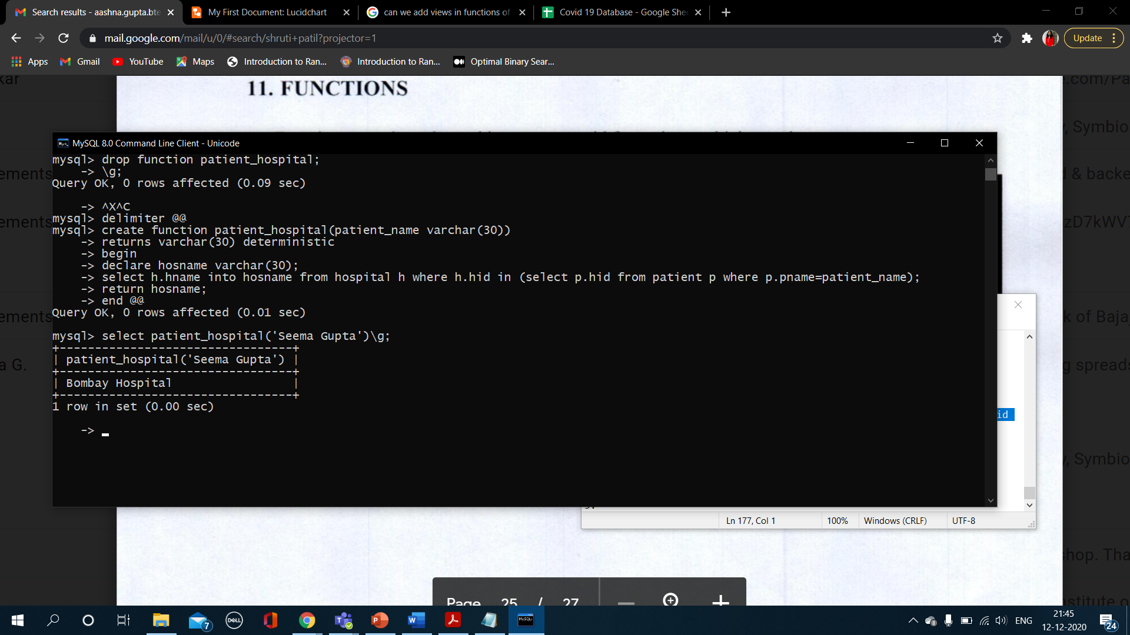

1. **Return the test type for given took id.**

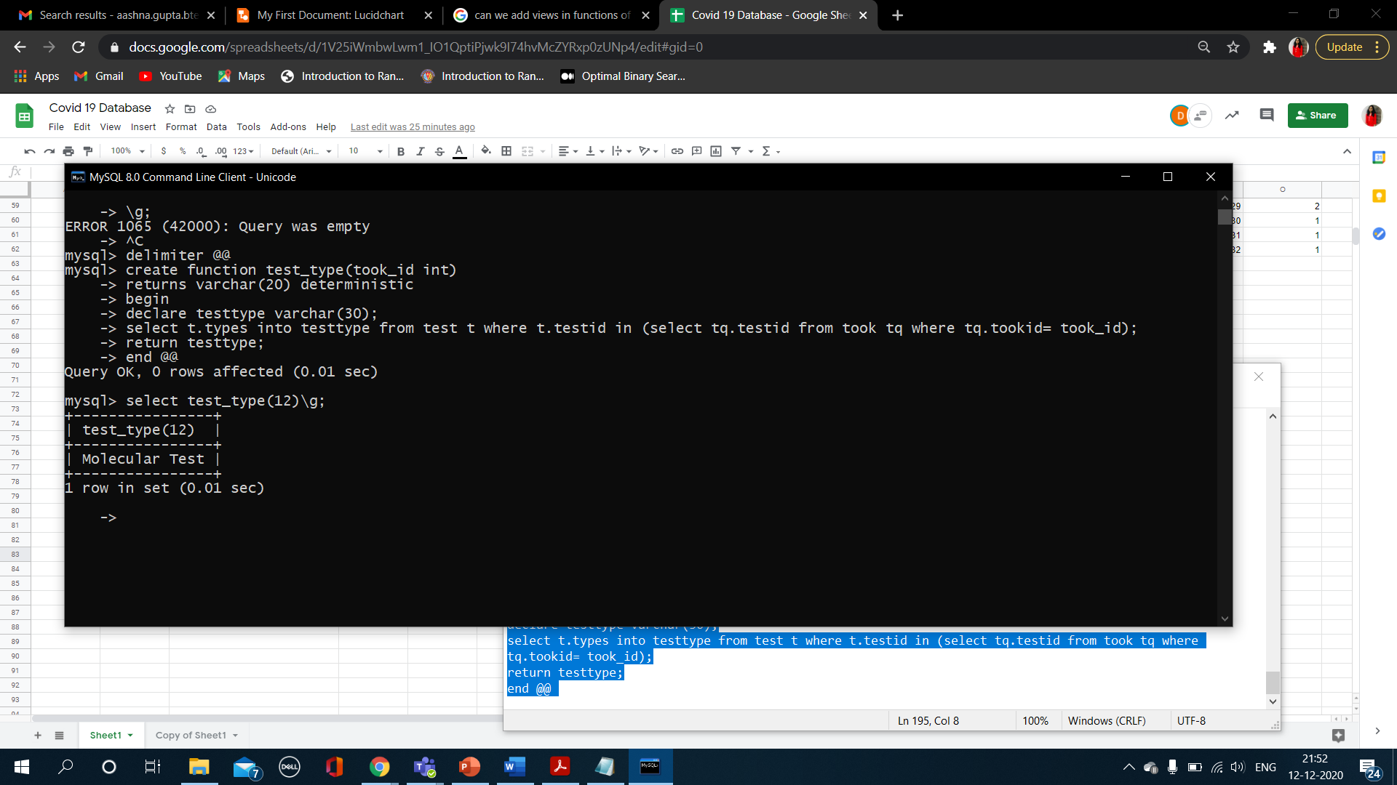

**Procedures-**

1. **List of symptoms treated by given home quarantined treatment.**

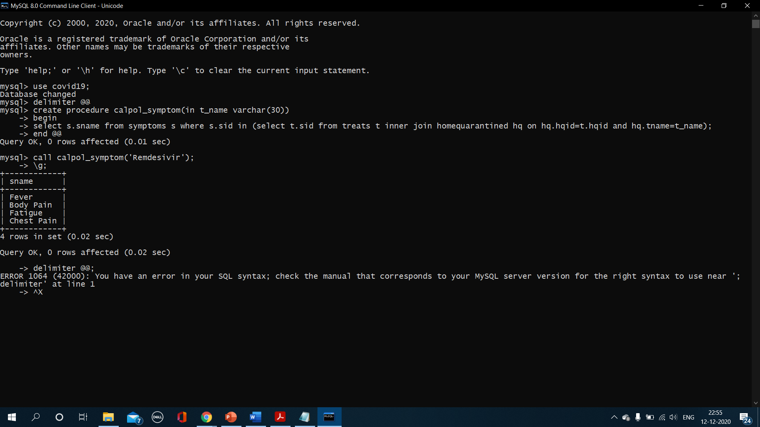

1. **Details of a particular test whose result is positive.**

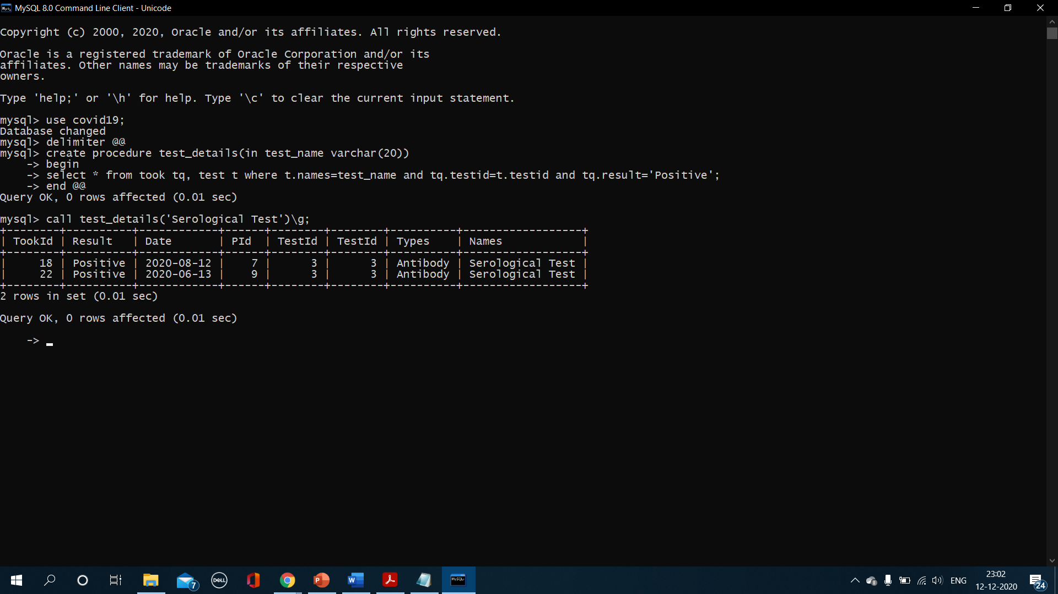

1. **Details of patients treated by the given doctor id.**

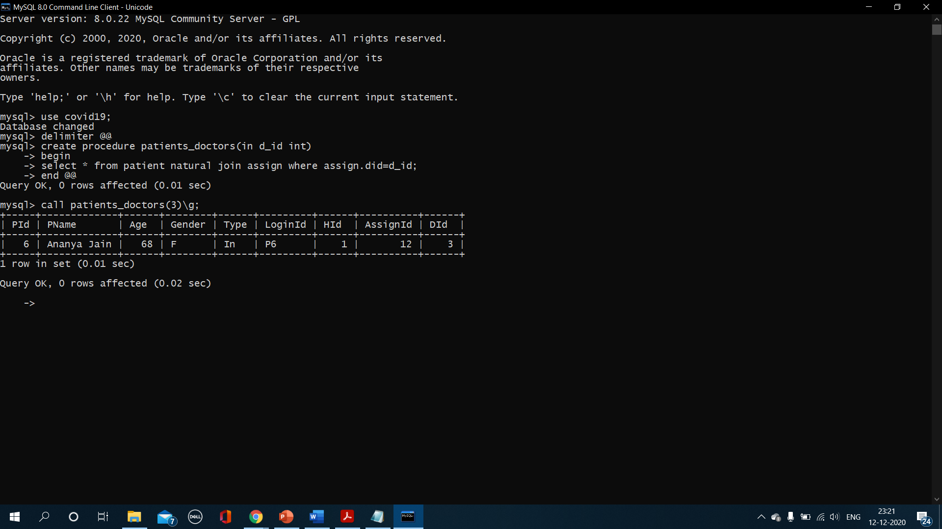

1. **List of Doctor details for a given hospital name.**

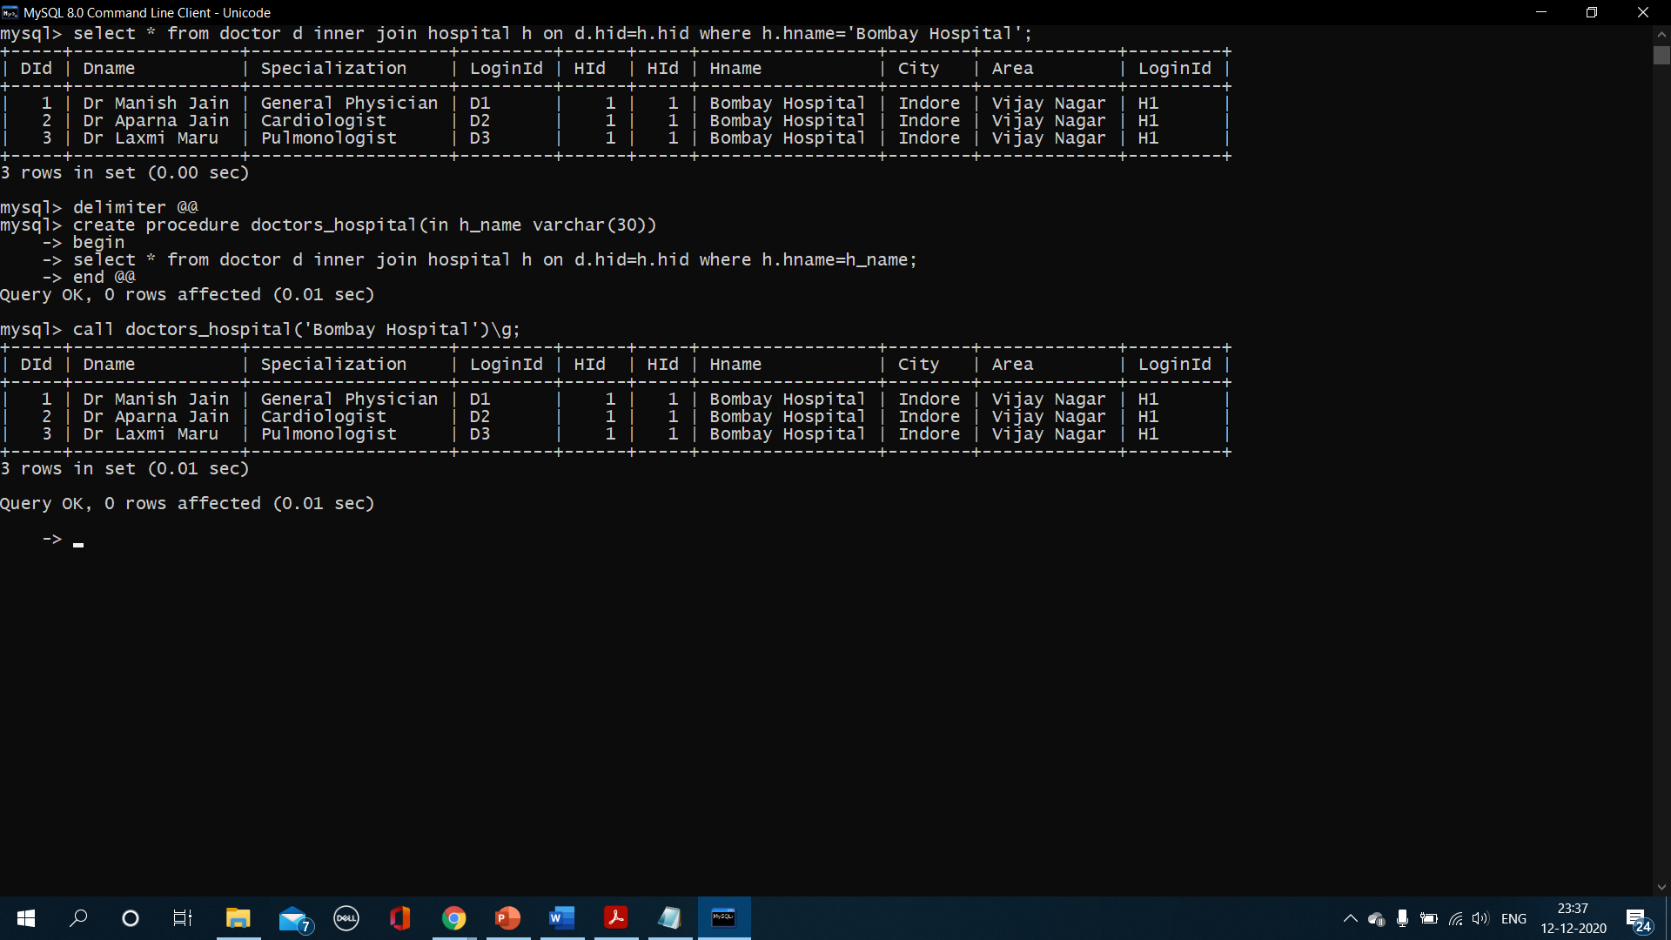

1. **Details of Patients and symptoms given the severity.**

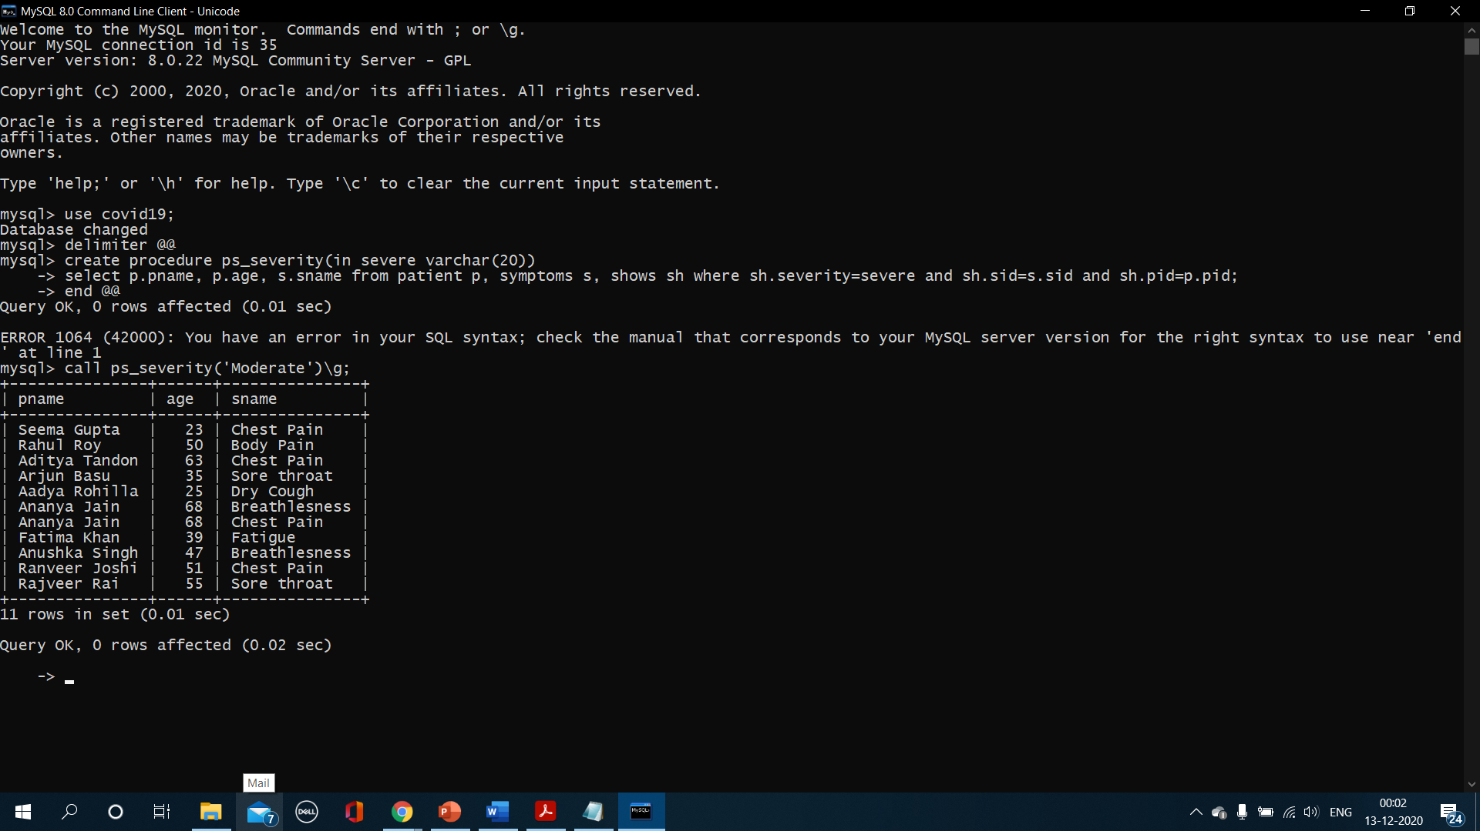

**Triggers-**

1. **Implementing AFTER update trigger for updating password.**

Creating trigger-

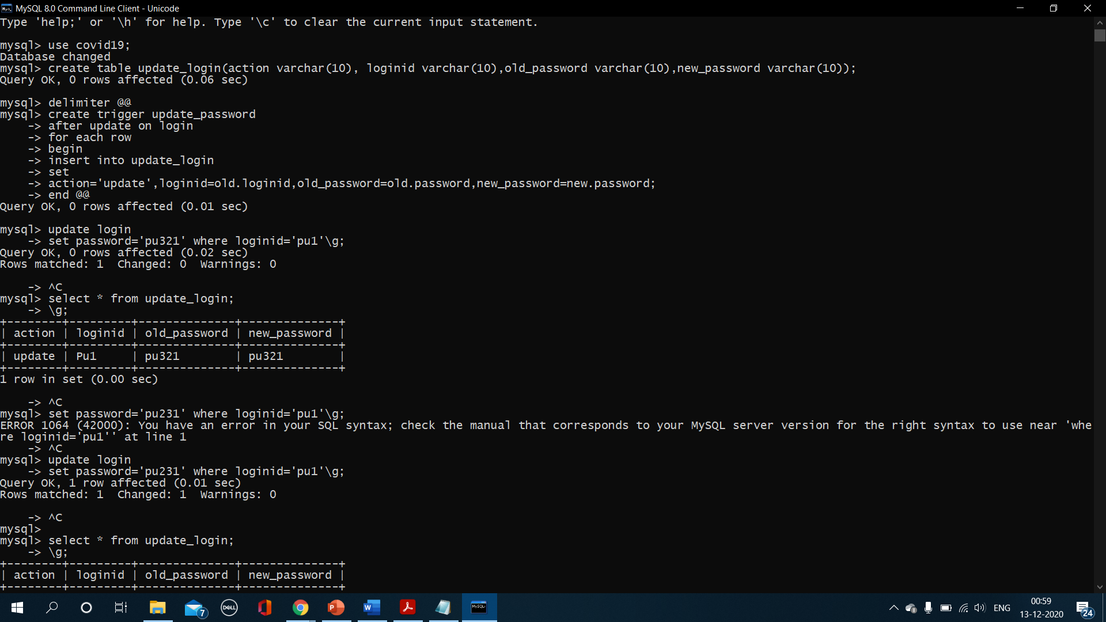

Updating password-

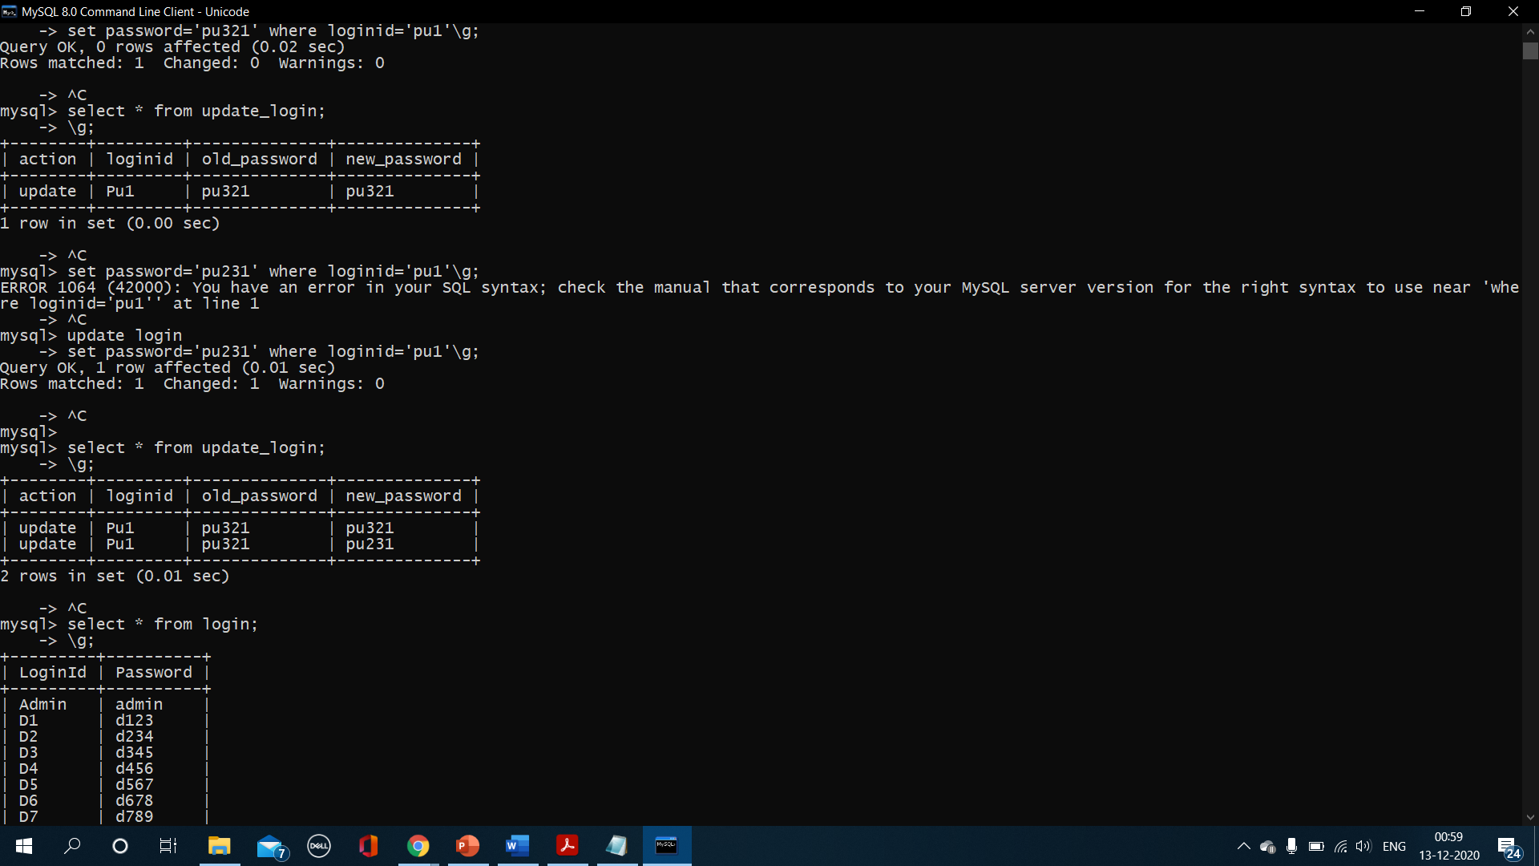

1. **Implementing BEFORE update trigger to give a warning if attempt is made to change the result.**

Creating trigger-

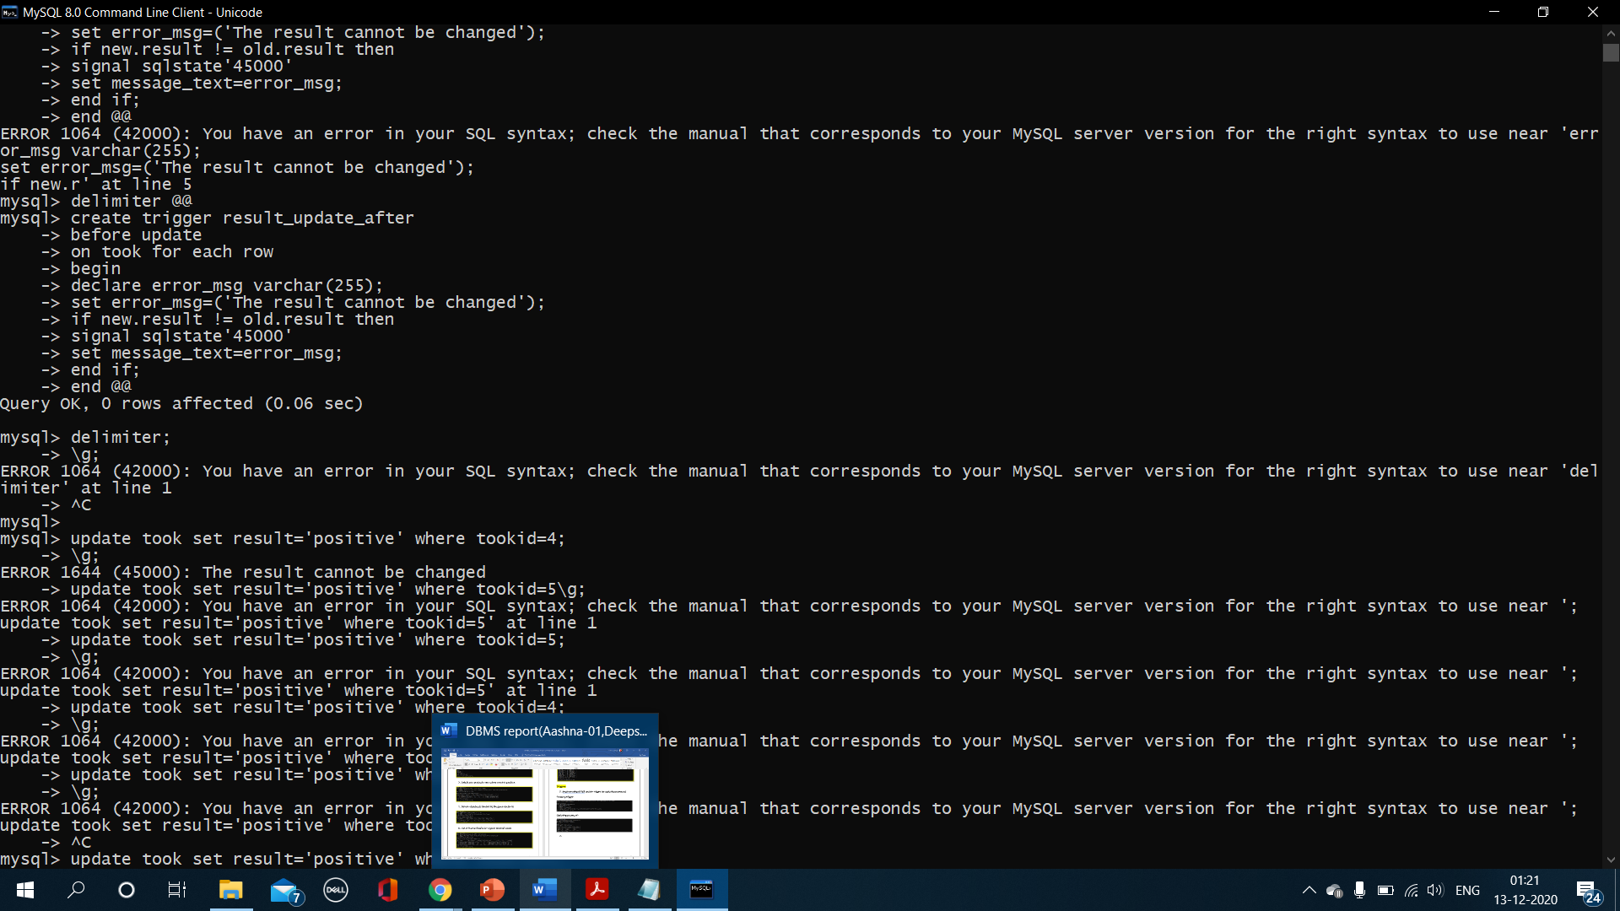

Updating result-

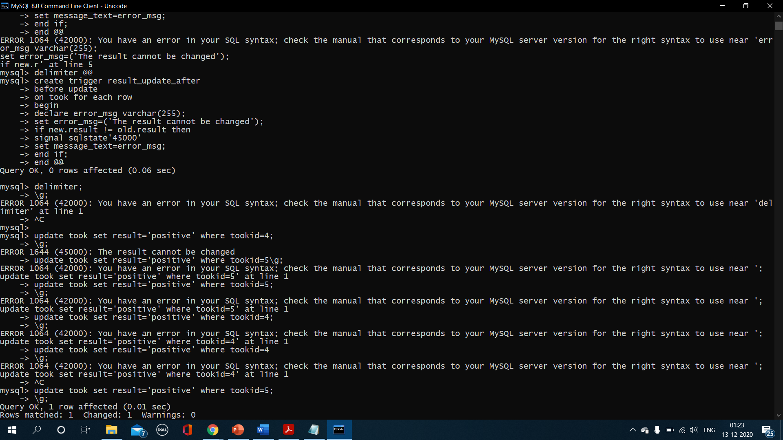

1. **Implementing BEFORE delete trigger on Login's table.**

Creating trigger-

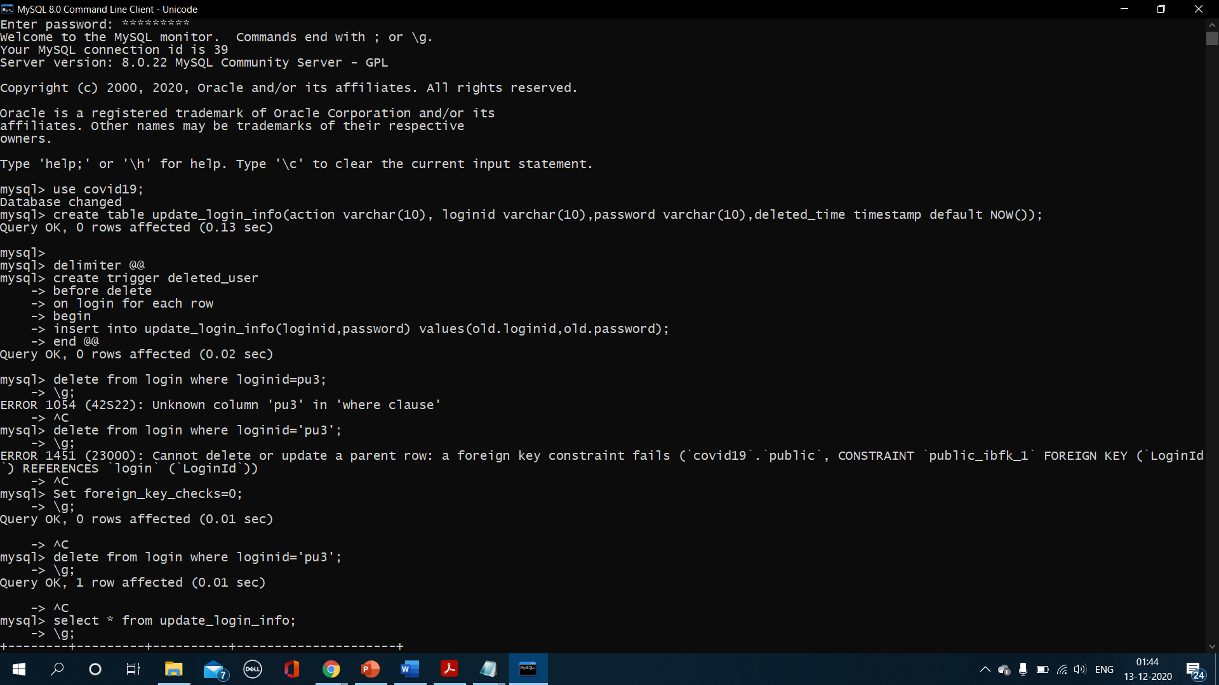

Deleting entry-



Log table-

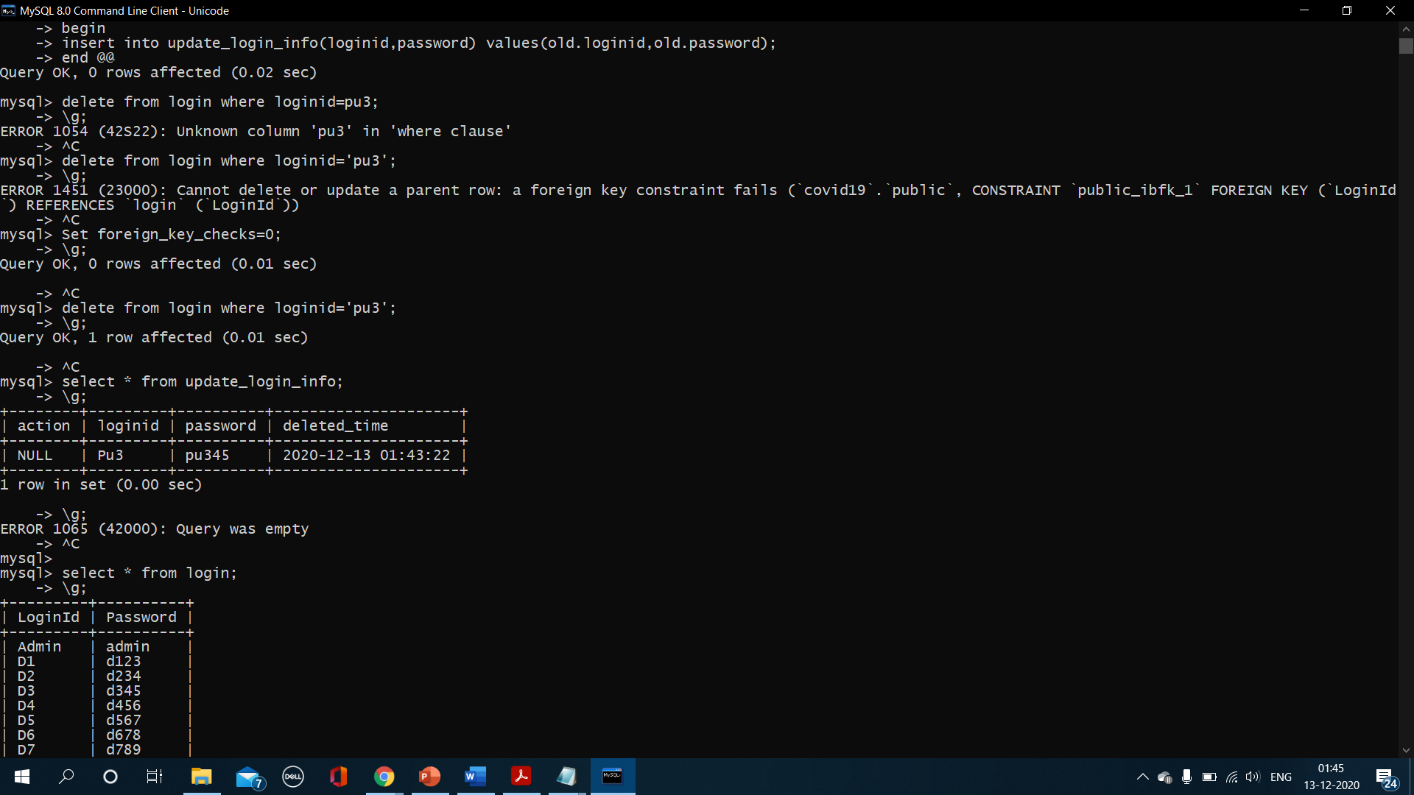

1. **Implementing BEFORE insert trigger on Hospital table.**

Creating trigger-

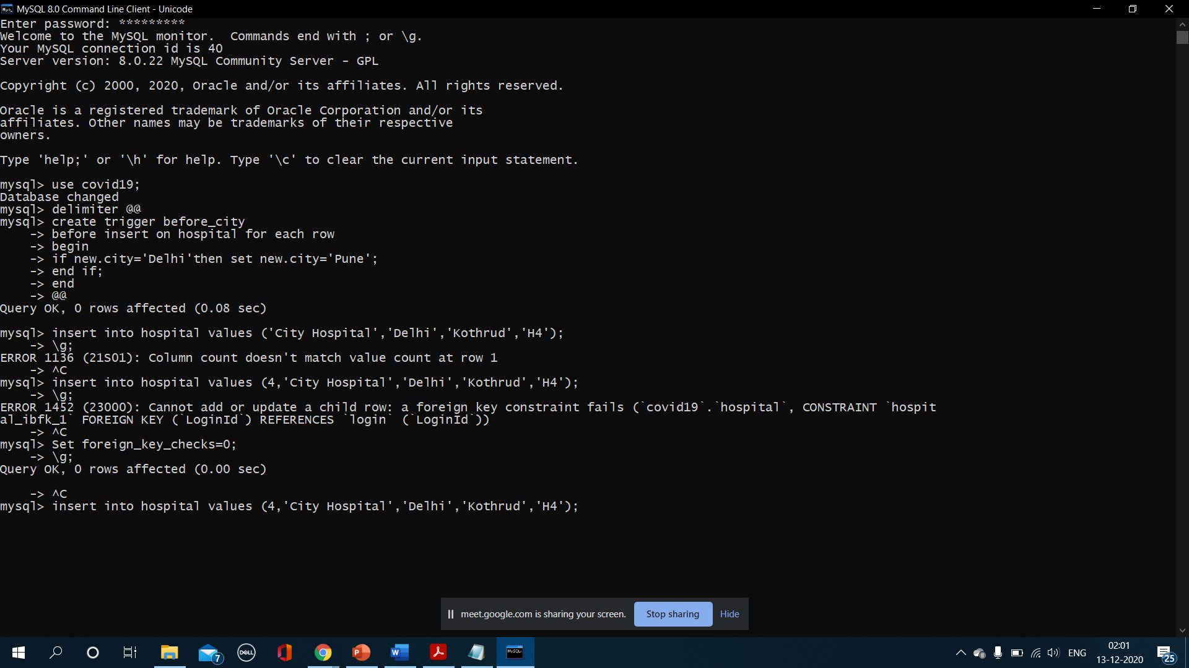

Inserting value-

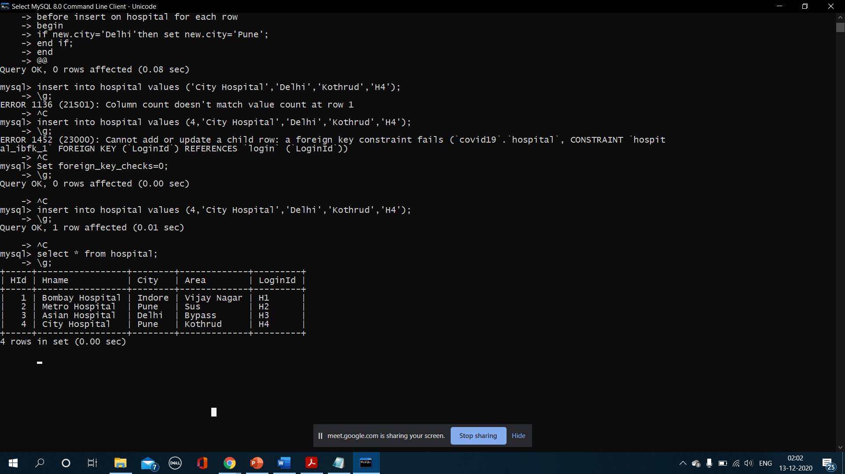

1. **Implementing AFTER insert trigger on the Doctor's data.**

Creating log table-

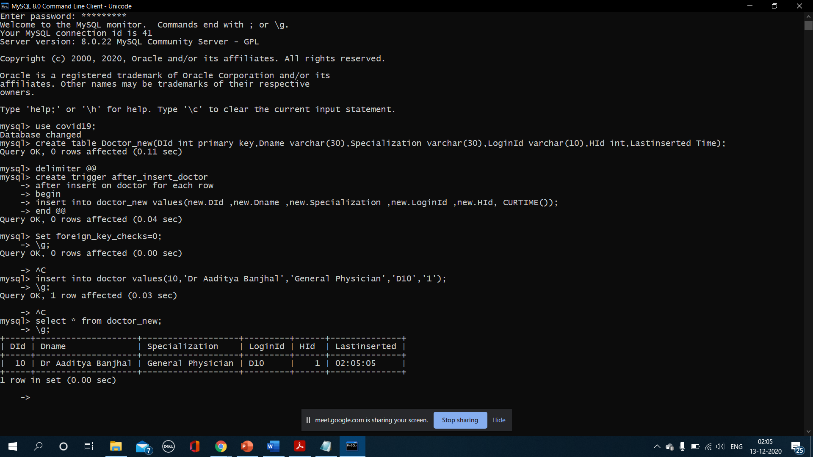

Creating trigger-



Inserting values-

